U.S. Radiocommunication Sector
FACT SHEET
Study Group: WP7B |  | Document No: US7B_27_032_R1
Reference: Annex 1 to the April 2025 WP7B Chairman’s Report Doc 7B/150,  Resolution 680 (WRC-23),  WRC-27 Agenda Item 1.15 |  | Date: 18 August 2025
Document Title:
Working document towards PDN Report ITU-R SA.[LUNAR_1.15_STUDIES]
Authors | Telephone |  | E-Mail
Dennis Lee, NASA/JPL  Cathy Sham, NASA/JSC  Scott Kotler, Lockheed Martin  Steve Baruch, NWSP for Lockheed Martin Corporation  Luciano Alexandre | 818-354-6908  281-222-1117  703-789-3923  240-476-2600  818-353-0663 |  | dennis.k.lee@jpl.nasa.gov  catherine.c.sham@nasa.gov  scott.kotler@LMCO.com  sbaruch@newwavespectrum.com  luciano.alexandre@jpl.nasa.gov
Purpose/Objective:
The purpose of this contribution is to further progress the working document in WP7B with sharing and compatibility studies per Res. 680 (WRC-23) resolves to invite… in time for 2027 World Radio Conference 1, 2 and 4
Abstract:
Under Agenda item 1.15 (WRC-27), possible new or modified space research service (space-to-space) allocations, in the frequency ranges identified in Resolution 680 (WRC-23) resolves to invite 1, are under study to ensure sharing and compatibility between SRS links on the lunar surface/between lunar orbit and lunar surface and incumbent services in Resolution 680 (WRC-23) recognizings g) to n) and RAS in adjacent and nearby bands.
At the April 2025 WP 7B meeting, some preliminary AI 1.15 sharing and compatibility studies with terrestrial services in the frequency ranges identified by RES 680 (WRC-23) were introduced. This contribution will provide additional studies and further progress the working document towards a Preliminary Draft New Report SA.[LUNAR 1.15 STUDIES].

Fact Sheet Preparer: Dennis Lee, NASA/JPL

Radiocommunication Study Groups | 
Source: Document 7B/TEMP/54  Reference: Resolution 680 (WRC-23)  Subject: WRC-27 agenda item 1.15 | Annex 1 to  Document 7B/150-E
 | 31 March 2025
 | English only
Annex 1 to Working Party 7B Chair’s Report
WORKING DOCUMENT TOWARDS A PRELIMINARY DRAFT
NEW REPORT ITU-R SA.[LUNAR 1.15 STUDIES]
Sharing studies of space research systems for lunar operations
under WRC-27 agenda item 1.15
(202X)
Scope

Keywords

Glossary / Abbreviations

Related ITU Recommendations and Reports

1 Introduction
This document provides the sharing studies and spectrum needs related to systems in the space research service planned for operations on the lunar surface, or systems in lunar orbit communicating with systems on the lunar surface, in the following frequency ranges or portions thereof:
– 390-406.1 MHz, 420-430 MHz and 440-450 MHz, limited to outside the SZM;
– 2 400-2 690 MHz, 3 500-3 800 MHz, 5 150-5 570 MHz, 5 570-5 725 MHz, 5 775-5 925 MHz, 7 190-7 235 MHz, 8 450-8 500 MHz and 25.25-28.35 GHz.
and taking into account protection of incumbent services in Resolution 680 (WRC-23) recognizing g) to n) and RAS on the Earth and in the shielded zone of the Moon (SZM) in the same, adjacent or nearby bands.
The objective of this document is to respond to resolves to invite the ITU Radiocommunication Sector to complete in time for the 2027 world radiocommunication conference 1) and 4) of Resolution 680 (WRC-23) under WRC-27 agenda item 1.15.

2 Spectrum needs
Figure 1 shows a conceptual diagram of the envisioned elements [1] used for space research operations on the lunar surface, and the associated communication network architecture in the vicinity of the Moon. The communication links between the lunar elements will be used to support scientific discovery and human/robotic exploration of the Moon, and may leverage technology and frequency ranges originally developed for wireless communication networks on Earth. A detailed description of the technical and operating characteristics of systems in the space research service planned for operations on the lunar surface, or systems in lunar orbit communicating with systems on the lunar surface, are provided in PDN Report ITU-R SA.[LUNAR.SRS STATIONS CHAR]. This section provides a description of the amount of spectrum needed within each frequency range needed to support the envisioned concept of operations as described in the aforementioned Report and summarized below.
Figure 1
Envisioned Lunar Surface Communication Architecture
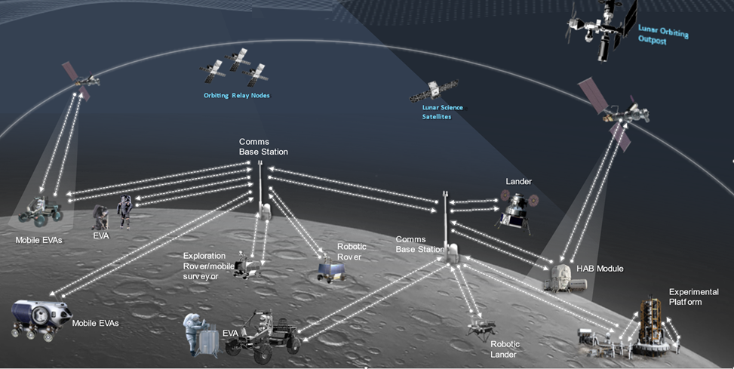
In this lunar communication network architecture, it is assumed that the initial human exploration activities will centered around the lunar landers, and eventually around permanent habitation modules. The lunar landers will be considered as a stationary surface platform for the duration of the landed mission phase, which may last up to several months. There will likely be multiple landers present on the lunar surface at any one time, some which may be crewed and others which are for robotic exploration only. There may also be multiple habitation modules, each with their own local area communication networks and high rate point-to-point links between habitation modules.
The lander and the habitation module are expected to provide a wireless local area network (WLAN) service for crew and rovers in the near vicinity of the lander (< 300 meters). The data rate for each device is expected to be between 1-30 Mbps including file transfers and high definition video, with up to 15-20 connected devices per WLAN. The frequency ranges for this application are expected to in the 2 400-2 483.5 MHz and 5 150-5 725 MHz bands using Wi-Fi technology. In addition, lunar terrain vehicles and pressurized rovers may also provide WLAN coverage in their immediate vicinity for crewed exploration of the Moon away from the lander/habitation modules.
For longer range connectivity around the lander and habitation modules, it is expected that network coverage will be provided by technology similar to 3GPP developed for terrestrial networks. The data rates per lunar device is expected to between 3-12 Mbps for voice, data, and video. Initial deployments on the Moon will likely involve a base station installed on the lunar lander supporting EVA communications for up to 6 lunar elements (crew and/or rovers) in a 2 km radius around the lander. This can be supported using a FDD network in the 2 500-2 690 MHz band, assuming a 50 MHz guard band between the FDD uplink and downlink bands. For crew contingency walk-back scenarios where coverage is limited or the range is large (up to 10 km), the data rate using this network may limited to 100 kbps.
Eventual deployment around the habitation module will involve multiple base stations for a larger coverage area and more lunar elements (up to approximately 30-50 devices). These networks may utilize the 3 500-3 800 MHz frequency range in order to provide a higher data rates (up to 100 Mbps per device) and increased network capacity. The lunar terrain vehicle and pressurized rover may also carry a base station to provide connectivity during long range crewed exploration missions away from the lander/habitation module.
During crewed exploration missions, short range crew suit-to-suit communications up to 200 meters distance is need for voice and data. The data rate for this application is expected to be around 100 kbps and will use the 420-430 MHz frequency range. For higher rate suit-to-suit communications involving high definition video (~12 Mbps), technology based on the Sidelink device-to-device communications in the 5 855-5 925 frequency band may also be used. Furthermore, the astronauts will carry a distress beacon in the 406-406.1 MHz band. This beacon will be used to notify a lunar orbiting satellite in the event of an emergency. The crew EVA suits and rovers will also carry devices to receive signals transmitted by lunar orbiting satellites for position determination and time synchronization in the 2 483.5-2 500 MHz band. Outside of the SZM, relay communications between elements on the lunar surface and lunar orbiting satellites may also take place in the 390-405 MHz and 440-450 MHz bands.
For high rate point-to-point links between the habitation module and remote experimental platforms involving science observations and/or data collection, the 27.5-28.35 GHz frequency range is expected be used. These links may involve data rates up to 1 Gbps using highly directional antennas. This frequency band may also be used for high rate communications between two habitation modules, or for relay communications between a lander and a habitation module.
Table 1 shows a calculation of the spectrum needs for different envisioned lunar SRS applications.
Table 1
Envisaged Concept of Operations of Spectrum Use for SRS Systems in the Lunar Environment
Frequency Band | Lunar Surface to Lunar Surface | Lunar Orbit to Lunar Surface | Lunar Surface to Lunar Orbit
390-405 MHz * |  | X
406-406.1 MHz * |  |  | X
420-430 MHz * | X
440-450 MHz * |  |  | X
2 400-2 483.5 MHz | X
2 483.5-2 500 MHz |  | X
2 500-2 690 MHz | X
3 500-3 800 MHz | X
5 150-5 570 MHz | X
5 570-5 725 MHz | X
5 725-5 855 MHz | X
5 855-5 925 MHz | X
7 190-7 235 MHz |  | X
8 450-8 500 MHz |  |  | X
27.5-28.35 GHz | X
* Outside of the Shielded Zone of the Moon.

Table 2
Lunar SRS Spectrum Needs
 | EVA Comms | HAB module | Point-to-point Surface Comms | Orbiter relay comms (proximity link) | Remote Science Instruments | Exploration Vehicle (LTV, pressurized rover)
Data Type | Voice, Data, Video | High rate data transfer, file upload, high definition video | Backhaul data | Relay data | Scientific measurement data | Voice, Data, Video
Data Rate (Mbps) | 12 | 30 | 1000 | 100 | 30 | 30
# of Devices/ Links per Site | 6-12 | TBD | TBD | 6  (forward and return) | 20 | 4
Total capacity (Mbps) | 144 | TBD | TBD | 600 | 600 | 120
Spectral efficiency (bits/s/Hz) | 1 | TBD | TBD | 2 | 2 | 1
Spectrum needs (MHz) | 144 | TBD | TBD | 300 | 300 | 120
Total Spectrum needs (MHz)⁽¹⁾ | TBD
⁽¹⁾ Not including bandwidth for backup communications and guard bands

3 Services identified for sharing and compatibility studies with space research systems for lunar communications
This section provides a summary of the services identified for sharing and compatibility studies with lunar surface SRS systems, or systems in lunar orbit communicating with systems on the lunar surface, in the frequencies ranges listed for study in Resolution 680 (WRC-23). The following tables provide a summary of the services identified for sharing and compatibility studies in each frequency range, along with the regions and relevant footnotes from Article 5 in the Radio Regulations.
The technical and operating characteristics of systems in the space research service planned for operations on the lunar surface, or systems in lunar orbit communicating with systems on the lunar surface, are provided in PDN Report ITU-R SA.[LUNAR.SRS STATIONS CHAR]. All the lunar communications described in this report are between or among types of space stations on the lunar surface or in lunar orbit.

3.1 390-406.1 MHz
TABLE 3
Services identified for sharing studies with lunar communications (390-406.1 MHz)
Service | Frequencies | Footnotes
FIXED | 390.0-399.9 MHz
FIXED | 400.15-401 MHz | 5.262
MOBILE | 390.0-399.9 MHz
MOBILE | 400.15-401 MHz | 5.262
MOBILE-SATELLITE  (Earth-to-space) | 399.9-400.05 MHz | 5.209, 5.220, 5.260A, 5.260B
MOBILE-SATELLITE  (Earth-to-space) | 406.00-406.10 MHz | 5.265, 5.266, 5.267
MOBILE-SATELLITE  (space-to-Earth) | 400.15-401.00 MHz | 5.208A, 5.208B, 5.209
Fixed⁽¹⁾ | 401-406 MHz
⁽¹⁾ Service allocated on a secondary basis as per Radio Regulations but identified for study by WP 5C.

3.2 420-430 MHz
TABLE 4
Services identified for sharing studies with lunar communications (420-430 MHz)
Service | Frequencies | Footnotes
FIXED | 420-430 MHz
MOBILE except aeronautical mobile | 420-430 MHz
RADIOLOCATION | 420-430 MHz | 5.269

3.3 440-450 MHz
TABLE 5
Services identified for sharing studies with lunar communications (440-450 MHz)
Service | Frequencies | Footnotes
FIXED | 440-450 MHz
MOBILE except aeronautical mobile | 440-450 MHz
RADIOLOCATION | 440-450 MHz | 5.269, 5.285

3.4 2 400-2 690 MHz
TABLE 6
Services identified for sharing studies with lunar communications (2 400-2 690 MHz)
Service | Frequencies | Footnotes
FIXED | 2 400-2 690 MHz
MOBILE | 2 400-2500 MHz
RADIOLOCATION | 2 450-2 500 MHz
RADIODETERMINATION-SATELLITE (space-to-Earth) | 2 483.5-2 500 MHz | 5.398, 5.399 (Region 1), 5.401 (Regions 1&3), 5.402
MOBILE-SATELLITE (space-to-Earth) | 2 483.5-2 500 MHz | 5.351A, 5.401 (Regions 1&3), 5.402
MOBILE-SATELLITE (space-to-Earth) | 2 500-2 520 MHz
MOBILE-SATELLITE  (Earth-to-space) | 2 655-2 670 MHz | 5.420
MOBILE-SATELLITE  (Earth-to-space) | 2 670-2 690 MHz | 5.351A
FIXED-SATELLITE  (space-to-Earth) | 2 500-2 535 MHz | 5.415
FIXED-SATELLITE  (space-to-Earth) | 2 535-2 655 MHz | 5.415
FIXED-SATELLITE  (space-to-Earth) | 2 655-2 690 MHz | 5.415
FIXED-SATELLITE  (Earth-to-space) | 2 655-2 690 MHz | 5.415
MOBILE except aeronautical mobile | 2 500-2 690 MHz | 5.384A, 5.409A (Regions 1&2)
MOBILE (identified for IMT) | 2 500-2 690 MHz | 5.384A
MOBILE (identified for HIBS) | 2 500-2 690 MHz | 5.409A
BROADCASTING-SATELLITE | 2 520-2 655 MHz | 5.413, 5.416, 5.418B, 5.418C
BROADCASTING-SATELLITE | 2 520-2 535 MHz | 5.413, 5.416
BROADCASTING-SATELLITE | 2 535-2 655 MHz | 5.413, 5.416, 5.418, 5.418A, 5.418B, 5.418C
BROADCASTING-SATELLITE | 2 655-2 670 MHz | 5.413, 5.416
AERONAUTICAL RADIONAVIGATION ⁽¹⁾ | 2 700-2 900 MHz | 5.423
NOTE: The frequency range from 2 400 to 2 500 MHz is also designated for industrial, scientific and medical (ISM) applications according RR No. 5.150. Radiocommunication services operating within these bands must accept harmful interference which may be caused by these applications. ISM equipment operating in these bands is subject to the provisions of No. 15.13.
⁽¹⁾ Service identified for compatibility analysis by WP 5B.

3.5 3 500-3 800 MHz
TABLE 7
Services identified for sharing studies with lunar communications (3 500-3 800 MHz)
Service | Frequencies | Footnotes
FIXED | 3 500-3 800 MHz
FIXED SATELLITE  (space-to-Earth) | 3 500-3 800 MHz
MOBILE except aeronautical mobile | 3 500-3 600 MHz | 5.430A (Region 1), 5.431B (Region 2), 5.433A (Region 3)
MOBILE except aeronautical mobile | 3 600-3 800 MHz | 5.434A (Region 1), 5.435A (Region 1), 5.433B (Region 1), 5.434B (Region 1), 5.434 (Region 2)
MOBILE (identified for IMT) | 3 500-3 600 MHz | 5.430A, 5.431B, 5.433A
MOBILE (identified for IMT) | 3 600-3 700 MHz | 5.434
MOBILE (identified for IMT) | 3 700-3 800 MHz | 5.434B
MOBILE (identified for IMT) | 3 700-3 800 MHz | 5.435B
RADIOLOCATION (Regions 2 and 3) | 3 500-3 600 MHz | 5.433

3.6 5 150-5 570 MHz
TABLE 8
Services identified for sharing studies with lunar communications (5 150-5 570 MHz)
Service | Frequencies | Footnotes
FIXED SATELLITE  (Earth-to-space) | 5 150-5 250 MHz | 5.447A, 5.447C
FIXED SATELLITE ⁽¹⁾  (space-to-Earth) | 5 150-5 216 MHz | 5.447B
MOBILE except aeronautical mobile | 5 150-5 250 MHz | 5.446A, 5.446B, 5.447
MOBILE except aeronautical mobile | 5 250-5 350 MHz | 5.446A, 5.447F
MOBILE except aeronautical mobile | 5 470-5 570 MHz | 5.446A, 5.450A
AERONAUTICAL MOBILE | 5 150 -5 250 MHz | 5.446C, 5.446D
AERONAUTICAL RADIONAVIGATION | 5 150-5 250 MHz
AERONAUTICAL RADIONAVIGATION | 5 350-5 460 MHz | 5.449
AERONAUTICAL RADIONAVIGATION | 5 470-5 650 MHz | 5.450
FIXED | 5 250-5 350 MHz | 5.447E
RADIOLOCATION | 5 250-5 350 MHz | 5.448A
RADIOLOCATION | 5 350-5 470 MHz | 5.448D
RADIOLOCATION | 5 470-5 570 MHz | 5.450B
SPACE RESEARCH (active) | 5 250-5 255 MHz | 5.447D
SPACE RESEARCH (active) | 5 255-5 350 MHz | 5.448A
SPACE RESEARCH (active) | 5 350-5 460 MHz | 5.448C
SPACE RESEARCH (active) | 5 460-5 570 MHz | 5.448B
RADIONAVIGATION | 5 250-5 350 MHz | 5.448
RADIONAVIGATION | 5 460-5 470 MHz | 5.448B, 5.449
MARITIME RADIONAVIGATION | 5 470-5 570 MHz | 5.448B
⁽¹⁾ This allocation is limited to feeder links of non-geostationary-satellite systems in the mobile satellite service and is subject to provisions of No. 9.11A.

3.7 5 570-5 725 MHz
TABLE 9
Services identified for sharing studies with lunar communications (5 570-5 725 MHz)
Service | Frequencies | Footnotes
RADIOLOCATION | 5 570-5 650 MHz | 5.450B
RADIOLOCATION | 5 650-5 725 MHz
FIXED | 5 650-5 725 MHz | 5.453, 5.455
MOBILE | 5 650-5 725 MHz | 5.453
MOBILE except aeronautical mobile | 5 570-5 725 MHz | 5.450A

3.8 5 775-5 925 MHz
TABLE 10
Services identified for sharing studies with lunar communications (5 775-5 925 MHz)
Service | Frequencies | Footnotes
FIXED SATELLITE  (Earth-to-space) | 5 775-5 850 MHz
FIXED SATELLITE  (Earth-to-space) | 5 850-5 925 MHz
RADIOLOCATION | 5 775-5 850 MHz
FIXED | 5 775-5 850 MHz | 5.453
FIXED | 5 850-5 925 MHz
MOBILE | 5 775-5 850 MHz | 5.453
NOTE: The frequency range from 5 725 to 5 875 MHz is also designated for industrial, scientific and medical (ISM) applications according RR No. 5.415A. Radiocommunication services operating within these bands must accept harmful interference which may be caused by these applications. ISM equipment operating in these bands is subject to the provisions of No. 15.13.

3.9 7 190-7 235 MHz
TABLE 11
Services identified for sharing studies with lunar communications (7 190-7 235 MHz)
Service | Frequencies | Footnotes
FIXED | 7 190-7 235 MHz
MOBILE | 7 190-7 235 MHz
SPACE RESEARCH  (Earth-to-space) | 7 190-7 235 MHz | 5.460, 5.459

3.10 8 400-8 500 MHz
TABLE 12
Services identified for sharing studies with lunar communications (8 450-8 500 MHz)
Service | Frequencies | Footnotes
FIXED | 8 450-8 500 MHz
MOBILE except aeronautical mobile | 8 450-8 500 MHz
SPACE RESEARCH  (space-to-Earth) | 8 450-8 500 MHz

3.11 25.25-28.35 GHz
TABLE 13
Services identified for sharing studies with lunar communications (25.25-28.35 GHz)
Service | Frequencies | Footnotes
FIXED | 25.25-27 GHz | 5.534A
FIXED | 27-27.5 GHz | 5.534A (Regions 2&3)
FIXED | 27.5-28.35 GHz | 5.537A
FIXED (identified for HAPS) | 25.25-27.5 GHz | 5.534A
INTER SATELLITE | 25.25-27.5 GHz | 5.536, 5.537 (Regions 2&3)
INTER SATELLITE | 27.5-28.35 GHz ⁽¹⁾ | 5.521A
MOBILE | 25.25-27.5 GHz | 5.532AB
MOBILE | 27.5-28.35 GHz
FIXED SATELLITE  (Earth-to-space) | 27-27.5 GHz
FIXED SATELLITE  (Earth-to-space) | 27.5-28.35 GHz | 5.484A, 5.516B, 5.517A, 5.539, 5.538, 5.540, 5.517B
⁽¹⁾ New intersatellite service allocation from WRC-23.

4 Technical and operational characteristics for sharing and compatibility studies
Technical and operational characteristics to be considered in the sharing and compatibility studies are presented in the table below, as provided by WP 7B and the contributing groups to WRC-27 agenda item 1.15.
Working Party 7B/ | Contributing Group | Services/Parameters
97/Annex 1 | WP 7B | Lunar SRS
58, 119 | WP 3J | Propagation models
- | WP 4A | Fixed-satellite service  Broadcasting-satellite service
41, 106 | WP 4C | Mobile-satellite service
115 | WP 5A | Land mobile service  Amateur and Amateur-satellite service
49, 114 | WP 5B | Aeronautical mobile service  Radiodetermination service
56 | WP 5C | Fixed service
64, 105 | WP 5D | International Mobile Telecommunications (IMT)
95 | WP 7A | Standard Frequency and Time Signal
- | WP 7B | Space research service  Earth exploration-satellite service
103 | WP 7C | Space research service (active)  Earth exploration-satellite service (passive)
101 | WP 7D | Radio astronomy service

5 Sharing and compatibility studies
The sharing and compatibility studies are presented in the Annexes to this document.
Annex 1: Sharing and compatibility studies of SRS for lunar operations in the frequency band 390-406.1 MHz
Annex 2: Sharing and compatibility studies of SRS or lunar operations in the frequency band 420-430 MHz
Annex 3: Sharing and compatibility studies of SRS for lunar operations in the frequency band 440-450 MHz
Annex 4: Sharing and compatibility studies of SRS for lunar operations in the frequency band 2 400-2 690 MHz
Annex 5: Sharing and compatibility studies of SRS for lunar operations in the frequency band 3 500-3 800 MHz
Annex 6: Sharing and compatibility studies of SRS for lunar operations in the frequency band 5 150-5 570 MHz
Annex 7: Sharing and compatibility studies of SRS for lunar operations in the frequency band 5 570-5 725 MHz
Annex 8: Sharing and compatibility studies of SRS for lunar operations in the frequency band 5 775-5 925 MHz
Annex 9: Sharing and compatibility studies of SRS for lunar operations in the frequency band 7 190-7 235 MHz
Annex 10: Sharing and compatibility studies of SRS for lunar operations in the frequency band 8 450-8 500 MHz
Annex 11: Sharing and compatibility studies of SRS LDRS (Lunar Data Relay Satellite) system operations in the frequency bands 7 190-7 235 MHz and 8 450-8 500 MHz
Annex 12: Sharing and compatibility studies of SRS for lunar operations in the frequency band 25.25-28.35 GHz

ANNEX 1
Sharing and compatibility studies of SRS for lunar operations
in the frequency band 390-406.1 MHz

A1.1 Sharing and compatibility of fixed service and SRS for lunar operations in the frequency band 390-406.1 MHz

A1.1.1 Study A [USA]

A.1.1.1.1 Technical and operational characteristics of SRS operating in the 390-406.1 MHz frequency range
The technical and operational characteristics for SRS systems are based on those available in the preliminary draft of the new report ITU-R SA.[LUNAR.SRS STATIONS CHAR], including Tables 3.3-2 and 3.3-4, as summarized in Table A.1.1.1.1.
Table A.1.1.1.1
Technical Characteristics of the SRS Systems
Station | Lunar Orbit Space Station Transmitter | Lunar Surface  Transmitter
Frequency range | 390-406 MHz | 406-406.1 MHz
Beam Type | Fixed | Fixed
Polarization | CP | CP
Peak Gain (dBi) | 0 | 0.0
Max. EIRP Density (dBW/Hz) | ‒63 | ‒27.5
Max. EIRP (dBW) | 0 | 2.5
Orbital Characteristics or Antenna Height | Apolune: 7 000-11 000 km  Perilune: 600-2 700 km | <5 m
Channel BW (MHz) | 2 | 0.05

A.1.1.1.2 Technical and operational characteristics of fixed service operating in the 390-406.1 MHz frequency range
The Document 7B/56 provides relevant technical information to support studies between SRS and Fixed Services (FS) under agenda item 1.15. The characteristics for FS for point-to-point (PP) systems are based on the information contained in the Report ITU-R F.2108, Table 1, as summarized in Table A.1.1.1.2.
Table A.1.1.1.2
Characteristics of the FS (PP) systems
Parameter | Value
Frequency range | 340-470 MHz
Modulation format | GMSK
Receiver noise bandwidth | 0.6 MHz
Antenna gain | 12 dBi
Feeder loss | 4.4 dB
Receiver thermal noise ${(N}_{rx})$ | −146.5 dBW
Protection criteria (I/N) | −6 dB

A.1.1.1.3 Propagation model
This sharing study includes the lunar SRS system in orbit and on the surface of the Moon, and fixed services operating on Earth's surface. Therefore, Working Party 3J in Document 7B/58 recommends using the propagation model based on Recommendation ITU-R P.525 for this scenario.

A.1.1.1.4 Methodology
The methodology employed in this study is based on a static analysis of both single and aggregated worst-case interference. It evaluates whether, even under conditions of perfect antenna coupling between the systems, at the minimum distance between the stations on Earth and the Moon, and in the absence of antenna pointing errors and losses such as depolarization and clutter, the interference levels comply with the established ITU-R service protection criteria.

A.1.1.1.5 Study results
The study was conducted in accordance with the scenario outlined in Figure A.1.1.1.1. For the worst-case analysis, the following assumptions were considered:
– Main beam antenna coupling between the potentially interfering lunar SRS transmitters and the FS victim receiver;
– Free space propagation loss assuming the minimum distance between the stations on the Earth and the Moon (355,000 km), while atmospheric, depolarization and clutter losses are not considered;
– In the present study, it is assumed that both systems operate at the same central frequency. A bandwidth correction factor (CF) is applied when the bandwidth of the potential interferer exceeds the bandwidth of the victim receiver under analysis. If the bandwidth of the interferer is equal to or smaller than that of the victim receiver, the bandwidth correction factor is 0:
$$CF = 10 * \log_{10}\left(\frac{{bandwidth}_{victim}}{{bandwidth}_{interferer}}\right)$$
– The aggregate interference-to-noise ratio (I/N) is calculated considering Lunar SRS transmitters pointing towards the FS victim receiver using the following equation:
$${\left(\frac{I}{N}\right)}_{Total}= \sum_{1}^{n}{{ ({EIRP}_{n}}_{θ,φ}+CF-FSPL-F_{loss}+{G_{rx}}_{θ,φ})-N_{rx})}$$
where n is the number of lunar surface transmitters; ${ {EIRP}_{n}}_{θ,φ}$is the equivalent isotropic radiated power of each lunar transmitter; FSPL is the free space path loss calculated using Recommendation ITU-R P.525; $F_{loss}$ is the FS feeder loss; ${{(G}_{rx})}_{θ,φ}$is the FS victim receiver maximum antenna gain; and $N_{rx}$ is the thermal noise power in the FS victim receiver bandwidth; CF is the frequency-dependent rejection based on the transmit and receiver bandwidths;
The single and aggregate I/N results are compared to the FS protection criteria (I/N ≤ −6 dB) to verify whether the FS protection is met
Figure A.1.1.1.1
SRS–FS Scenario
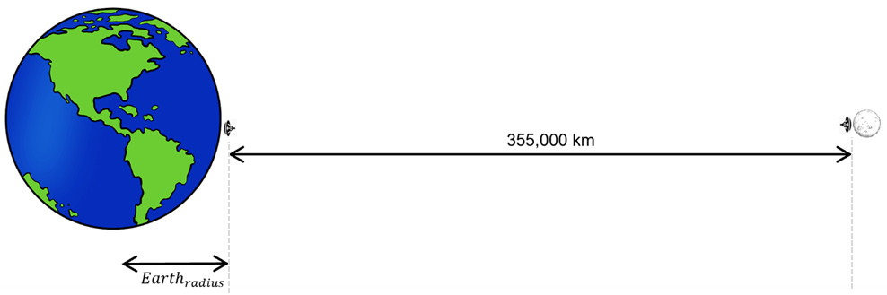
Table A.1.1.1.3
SRS - FS co-channel results
SRS Station | SRS center frequency | Analysis | I/N result | Margin to the FS protection criteria
Lunar Surface Transmitter | 391 MHz | Single Entry | -46.3 dB | 40.3 dB
Lunar Orbit Space Station Transmitter | 406.0025 MHz | Single Entry | -38.8 dB | 32.8 dB

A.1.1.1.6 Summary and analysis of the results of Study A
The interference-to-noise ratio metric shows that even in the single entry static worst-case analysis, there is a margin of at least 32.8 dB to satisfy the FS protection criteria. That also implies that aggregating over 1 900 simultaneously transmitting worst case towards the Earth interfering transmitters would still meet the FS protection criteria, which far exceeds the expected active number of lunar transmitters in this band. Thus the results of this static worst case study suggest that sharing between SRS and terrestrial FS operating in the 390-406.1 MHz band (co-channel) is feasible.

A1.1.2 Study B

A1.1.3 Study C

A1.2 Sharing studies between mobile satellite service (MSS) and SRS operating in the frequency band 390-406.1 MHz

A1.2.1 Study A [USA]

A.1.2.1.1 Technical and operational characteristics of SRS operating in the 390-406.1 MHz frequency range
The technical and operational characteristics for SRS systems are based on those available in the preliminary draft of the new report ITU-R SA.[LUNAR.SRS STATIONS CHAR], including Table 3.3-4, as summarized in Table A.1.2.1.1.
Table A.1.2.1.1
Technical Characteristics of the SRS Systems
Station | Lunar Orbit Space Station Transmitter
Frequency range | 390-406 MHz
Beam Type | Fixed
Polarization | CP
Peak Gain (dBi) | 0
Max. EIRP Dens  ity (dBW/Hz) | ‒63
Max. EIRP (dBW) | 0
Orbital Characteristics | Apolune: 7 000-11 000 km  Perilune: 600-2 700 km
Channel BW (MHz) | 2

A.1.2.1.2 Technical and operational characteristics of mobile satellite service (MSS) operating in the 390-406.1 MHz frequency range
Document 7B/41 provides relevant technical information to support studies between SRS and mobile satellite service (MSS) under Agenda Item 1.15. The technical characteristics and protection criteria used in this study were extracted from Recommendation ITU-R M.2046 for non-geostationary (non-GSO) MSS systems (Earth-to-space) operating in the 399.9-400.05 MHz band, and from Recommendation ITU-R M.1184 for MSS (space-to-Earth) systems operating in the 400.15-401 MHz band, as summarized in Table A.1.2.1.2.
In the absence of protection criteria defined in ITU-R Recommendations, Document 7B/41 recommends using a ΔT/T criterion of 6%. This criterion is currently found in Table 5-1 of RR Appendix 5 and serves as the coordination criterion between GSO MSS networks. Additionally, according to Document 7B/106, there is no available characteristics or protection criteria available for MSS systems in the 406-406.1 MHz band, so no particular study for this frequency range was conducted.
Table A.1.2.1.2
Characteristics of the MSS Systems
Parameter | MSS (Earth-to-space) | MSS (space-to-Earth)
Frequency range | 399-400.05 MHz | 400.6-400.9 MHz
System | non-GSO (ARGOS 4) | non-GSO
System noise temperature (K) / Receiver noise figure (dB) | 1214 K | 3.8 dB*
Antenna gain | 3.85 dBi | 7 dBi
Receiver bandwidth | 1.6 kHz | 300 kHz
Protection criteria | spfd ≤ –197.9 dB(W/(m² · Hz)) | I/N ≤ -12.2 dB
*Assumed parameter (no available receiver noise figure value)

A.1.2.1.3 Propagation model
This sharing study includes the lunar SRS system both in orbit and on the surface of the Moon, as well as MSS systems orbiting the Earth and operating on its surface. Therefore, Working Party 3J in Document 7B/58 recommends using the propagation model based on Recommendation ITU-R P.525 for those scenarios.

A.1.2.1.4 Methodology
The methodology employed in this study is based on a static analysis of both single and aggregated worst-case interference. It evaluates whether, even under conditions of perfect antenna coupling between the systems, at the minimum distance between the stations on Earth and the Moon, and in the absence of antenna pointing errors and losses such as depolarization and clutter, the interference levels comply with the established ITU-R service protection criteria.

A.1.2.1.5 Study results
The study was conducted in accordance with the scenarios outlined in Figure A.1.2.1.1. For the worst-case analysis, the following assumptions were considered:
– Main beam antenna coupling between the potentially interfering lunar SRS transmitters and the MSS victim receiver.
– For the MSS (space-to-Earth), the free space propagation loss assumes a minimum distance of 355,000 km between the stations on Earth and the Moon, as presented in Figure A.1.2.1.1 (b). Atmospheric, depolarization, and clutter losses are not considered.
– In the present study, it is assumed that both systems operate at the same central frequency. A bandwidth correction factor (CF) is applied when the bandwidth of the potential interferer exceeds the bandwidth of the victim receiver under analysis. If the bandwidth of the interferer is equal to or smaller than that of the victim receiver, the bandwidth correction factor is 0.
$$CF = 10 * \log_{10}\left(\frac{{bandwidth}_{victim}}{{bandwidth}_{interferer}}\right)$$
– The aggregate interference-to-noise ratio (I/N) is calculated considering Lunar SRS transmitters pointing towards the MSS victim receiver using the following equation:
$${\left(\frac{I}{N}\right)}_{Total}= \sum_{1}^{n}{{ ({EIRP}_{n}}_{θ,φ}+CF-FSPL+{G_{rx}}_{θ,φ})-N_{rx})}$$
where n is the number of lunar surface transmitters; ${ {EIRP}_{n}}_{θ,φ}$is the equivalent isotropic radiated power of each lunar transmitter; FSPL is the free space path loss calculated using Recommendation ITU-R P.525; ${{(G}_{rx})}_{θ,φ}$is the MSS victim receiver maximum antenna gain; and $N_{rx}$ is the thermal noise power in the MSS victim receiver bandwidth
– The receiver thermal noise power is calculated from the receiver noise figure (NF) using the formula provided in Recommendation ITU-R P.372-17.
– For the MSS (Earth-to-space), considering a satellite orbiting the Earth, the free space propagation loss assumes a non-GSO altitude of 650 km. This results in a minimum distance of 354,350 km between the stations on Earth and the Moon, as presented in Figure A.1.2.1.1(a)
– For the MSS (Earth-to-space), the aggregate interference spectral flux density (SFD) to the MSS space receiver is calculated as shown below, considering Lunar SRS potential interferers
$${\left(I\right)}_{Total}= \sum_{1}^{n}{{ ({EIRP}_{n}}_{θ,φ}+CF-FSPL+{{(G}_{rx})}_{θ,φ})}$$
$${\left(SFD\right)}_{Total}= \sum_{1}^{n}{\left(10*\log_{10}\left(\frac{{10}^{\frac{I_{total}}{10}}}{{Antenna}_{effective area}*Bandwidth}\right)\right)}$$
– The single and aggregate interference results are compared to the MSS protection criteria to verify whether the service protection criteria is met
Figure A.1.2.1.1
SRS–MSS Scenarios: (a) MSS (Earth-to-space); (b) MSS (space-to-Earth)
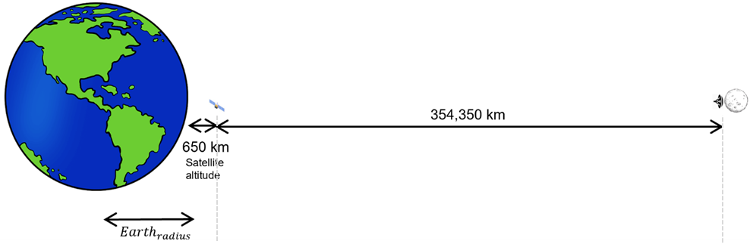
(a)
(b)
Table A.1.2.1.3
SRS – MSS (Earth-to-space) co-channel results
SRS Station | SRS center frequency | Analysis | SFD result  dB(W/m²*Hz) | Margin to the MSS protection criteria
Lunar Orbit Space Station Transmitter | 400 MHz | Single Entry | −244.9 | 47.0 dB
Table A.1.2.1.4
SRS – MSS (space-to-Earth) co-channel results
SRS Station | SRS center frequency | Analysis | I/N result | Margin to the MSS protection criteria
Lunar Orbit Space Station Transmitter | 400.8 MHz | Single Entry | −51.2 | 39.0 dB

A.1.2.1.6 Summary and analysis of the results of Study A
The interference metrics show that even in the single entry static worst-case analysis, there is a margin of at least 39 dB to satisfy the MSS protection criteria. That also implies that aggregating over 7900 worst case interfering transmitters would still meet the MSS protection criteria, which far exceeds the expected number of lunar transmitters in this band. Thus the results of this study suggest that sharing between SRS Lunar orbit transmitters and MSS systems operating in the 390-406.1 MHz band (co-channel) is feasible.

A1.3 …

A1.[X] Summary and analysis of the results of studies
[Note: The summary should offer an objective overview, encompassing the results of sharing and compatibility studies, alongside any pertinent information applicable for future comparisons among studies. Additionally, it should address any mitigation techniques or proposals employed to safeguard services operating within the same band or adjacent bands, where applicable, to SRS lunar systems.]

ANNEX 2
Sharing and compatibility studies of SRS for lunar operations
in the frequency band 420-430 MHz

A2.1 Sharing studies between fixed service and SRS for lunar operations in the frequency band 420-430 MHz

A2.1.1 Study A [USA]

A.2.1.1.1 Technical and operational characteristics of SRS operating in the 420-430 MHz frequency range
The technical and operational characteristics for SRS systems are based on those available in the preliminary draft of the new Report ITU-R SA.[LUNAR.SRS STATIONS CHAR], including Table 3.2-4, as summarized in Table A.2.1.1.1.
Table A.2.1.1.1
Technical Characteristics of the SRS Systems
Station | Lunar Surface-to-Surface Transmitter
Frequency range | 420 – 430 MHz
Polarization | Vertical
Peak Gain (dBi) | 0.0
EIRP Density (dBW/MHz) | ‒0.4
Max. EIRP (dBW) | 2.6
Channel BW (MHz) | 2

A.2.1.1.2 Technical and operational characteristics of fixed service operating in the 420– 430 MHz frequency range
The Document 7B/56 provides relevant technical information to support studies between SRS and Fixed Services (FS) under agenda item 1.15. The characteristics for fixed service (FS) for point-to-point (PP) systems are based on the information contained in the draft revision of Recommendation ITU-R F.758-7, Table 17, as summarized in Table A.2.1.1.2.
Table A.2.1.1.2
Characteristics of the FS (PP) systems
Parameter | Value
Frequency range | 406.1- 450 MHz
Reference | Recommendation ITU-R F.1567
Modulation format | 32-QAM
Receiver noise bandwidth | 3.5 MHz
Antenna height | 30 m
Antenna pattern | Recommendation ITU-R F.699
Antenna gain | 25 dBi
Feeder loss | 2 dB
Receiver noise figure | 3.5 dB
Protection criteria (I/N) | ‒6 dB

A.2.1.1.3 Propagation model
This sharing study includes the lunar SRS system on the surface of the Moon, and fixed services operating on Earth's surface. Therefore, Working Party 3J in Document 7B/58 recommends using the propagation model based on Recommendation ITU-R P.525 for this scenario.

A.2.1.1.4 Methodology
The methodology employed in this study is based on a static analysis of both single and aggregated worst-case interference. It evaluates whether, even under conditions of perfect antenna coupling between the systems, at the minimum distance between the stations on Earth and the Moon, and in the absence of antenna pointing errors and losses such as depolarization and clutter, the interference levels comply with the established ITU-R service protection criteria.

A.2.1.1.5 Study results
The study was conducted in accordance with the scenario outlined in Figure A.2.1.1.1. For the worst-case analysis, the following assumptions were considered:
– Main beam antenna coupling between the potentially interfering lunar SRS transmitters and the FS victim receiver.
– Free space propagation loss assuming the minimum distance between the stations on the Earth and the Moon (355,000 km), while atmospheric, depolarization and clutter losses are not considered.
– The aggregate interference-to-noise ratio (I/N) is calculated considering Lunar SRS transmitters pointing towards the FS victim receiver using the following equation:
$${\left(\frac{I}{N}\right)}_{Total}= \sum_{1}^{n}{{ ({EIRP}_{n}}_{θ,φ}-FSPL-F_{loss}+{G_{rx}}_{θ,φ})-N_{rx}}$$
where n is the number of lunar surface transmitters; ${ {EIRP}_{n}}_{θ,φ}$is the equivalent isotropic radiated power of each lunar transmitter; FSPL is the free space path loss calculated using Recommendation ITU-R P.525; $F_{loss}$ is the FS feeder loss; ${{(G}_{rx})}_{θ,φ}$is the FS victim receiver maximum antenna gain; and $N_{rx}$ is the thermal noise power in the FS victim receiver bandwidth.
– The receiver thermal noise power is calculated from the receiver noise figure (NF) using the formula provided in Recommendation ITU-R P.372-17.
– The single and aggregate I/N results are compared to the FS protection criteria (I/N ≤ −6 dB) to verify whether the FS protection is met.
Figure A.2.1.1.1
SRS–FS Scenario
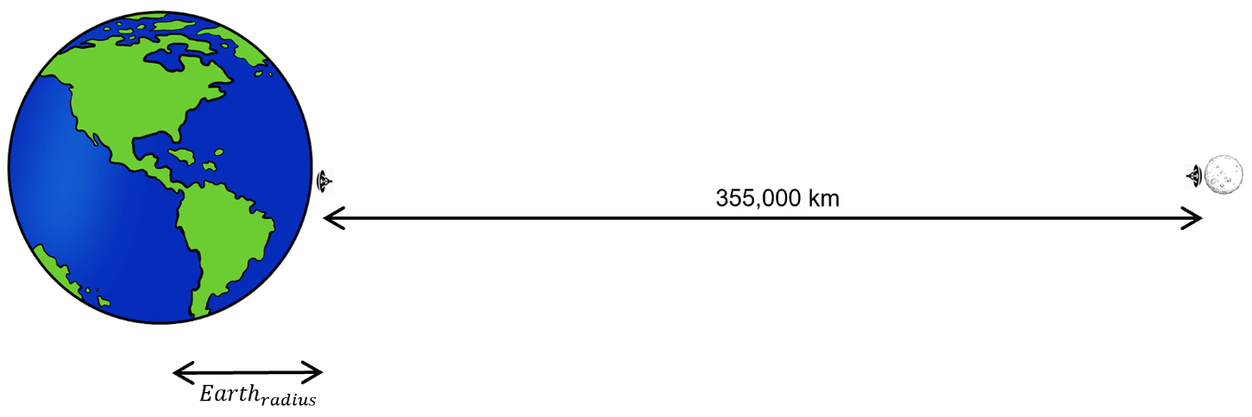
Table A.2.1.1.3
SRS - FS co-channel results
SRS Station | SRS center frequency | Analysis | I/N result | Margin to the FS protection criteria
Lunar Surface Transmitter | 425 MHz | Single Entry | –35.3 dB | 29.3 dB

A.2.1.1.6 Summary and analysis of the results of Study A
The interference-to-noise ratio metric shows that in the single entry static worst-case analysis, there is a margin of at least 29.3 dB to satisfy the FS protection criteria. That also implies that aggregating over 850 worst case interfering transmitters would still meet the FS protection criteria, which far exceeds the expected number of lunar transmitters in this band. The results of this study suggest that sharing between SRS and ground-based FS operating in the 420-430 MHz band (co-channel) is feasible.

A2.1.2 Study B

A2.1.3 Study C

A2.2 Sharing studies between radiolocation service and SRS operating in the frequency band 420-430 MHz

A2.1.1 Study A [USA]

A.2.2.1.1 Technical and operational characteristics of SRS operating in the 440-450 MHz frequency range
The technical and operational characteristics for SRS systems are based on those available in the preliminary draft of the new report ITU-R SA.[LUNAR.SRS STATIONS CHAR], including Table 3.2-4, as summarized in Table A.2.2.1.1.
Table A.2.2.1.1
Technical Characteristics of the SRS Systems
Station | Lunar Surface-to-Surface Transmitter
Frequency range | 420-430 MHz
Polarization | Vertical
Peak Gain (dBi) | 0.0
EIRP Density (dBW/MHz) | ‒0.4
Max. EIRP (dBW) | 2.6
Channel BW (MHz) | 2

A.2.2.1.2 Technical and operational characteristics of radiolocation service operating in the 420-430 MHz frequency range
The document 7B/114 provides relevant technical information to support studies between SRS and radars operating in the radiolocation service under Agenda Item 1.15. The characteristics for radars systems are based on the Recommendation ITU-R M.1462, Tables 1, 3 and 4, as summarized in Table A.2.2.1.2.
Table A.2.2.1.2
Characteristics of the radar systems
Parameter | Ground | Airborne | Shipborne
Frequency range | 420-450 MHz
Polarization | Circular | Horizontal | -
Platform height/altitude | 15 m | Ascent, descent and operational operations. Ceiling is around 9 km | -
Antenna gain | 40 dBi | 22 dBi | 30 dBi
Antenna scan | Sector ±60° azimuth scan, with rotating or random modes 3-85° elevation | ±60° elevation (mechanically positioned or electronically scanned); 360⁰ azimuth at 3-7 rpm | 360⁰ azimuth
Receiver noise figure | 4 dB | 5 dB | 4 dB
Receiver IF bandwidth | 2 MHz | 1 MHz | 2 MHz
Protection criteria (I/N) | −6 dB

A.2.2.1.3 Propagation model
This sharing study includes the lunar SRS system on the surface of the Moon, and radiolocation service operating on Earth's surface. Therefore, Working Party 3J in Document 7B/58 recommends using the propagation model based on Recommendation ITU-R P.525 for this scenario.

A.2.2.1.4 Methodology
The methodology employed in this study is based on a static analysis of both single and aggregated worst-case interference. It evaluates whether, even under conditions of perfect antenna coupling between the systems, at the minimum distance between the stations on Earth and the Moon, and in the absence of antenna pointing errors and losses such as depolarization and clutter, the interference levels comply with the established ITU-R service protection criteria.

A.2.2.1.5 Study results
The study was conducted in accordance with the scenarios outlined in Figure A.2.2.1.1. For the worst-case analysis, the following assumptions were considered:
– Main beam antenna coupling between the potentially interfering lunar SRS transmitters and the radar victim receiver.
– Free space propagation loss assuming the minimum distance between the stations on the Earth and the Moon (355,000 km for ground and shipborne radars and 354,991 km for airborne), while atmospheric, depolarization and clutter losses are not considered.
– In the present study, it is assumed that both systems operate at the same central frequency. A bandwidth correction factor (CF) is applied when the bandwidth of the potential interferer exceeds the bandwidth of the victim receiver under analysis. If the bandwidth of the interferer is equal to or smaller than that of the victim receiver, the bandwidth correction factor is 0:
$$CF = 10 * \log_{10}\left(\frac{{bandwidth}_{victim}}{{bandwidth}_{interferer}}\right)$$
– The aggregate interference-to-noise ratio (I/N) is calculated considering Lunar SRS transmitters pointing towards the radar victim receiver using the following equation:
$${\left(\frac{I}{N}\right)}_{Total}= \sum_{1}^{n}{{ ({EIRP}_{n}}_{θ,φ}+CF-FSPL+{G_{rx}}_{θ,φ})-N_{rx})}$$
where n is the number of lunar surface transmitters; ${ {EIRP}_{n}}_{θ,φ}$is the equivalent isotropic radiated power of each lunar transmitter; FSPL is the free space path loss calculated using Recommendation ITU-R P.525; ${{(G}_{rx})}_{θ,φ}$is the radar victim receiver maximum antenna gain; and $N_{rx}$ is the thermal noise power in the radar victim receiver bandwidth.
– The receiver thermal noise power is calculated from the receiver noise figure (NF) using the formula provided in Recommendation ITU-R P.372-17.
– The single and aggregate I/N results are compared to the radar protection criteria (I/N ≤ −6 dB) to verify whether the radiolocation service protection is met.
Figure A.2.2.1.1
SRS–RLS Scenarios: (a) Ground and shipborne; (b) Airborne
(a)
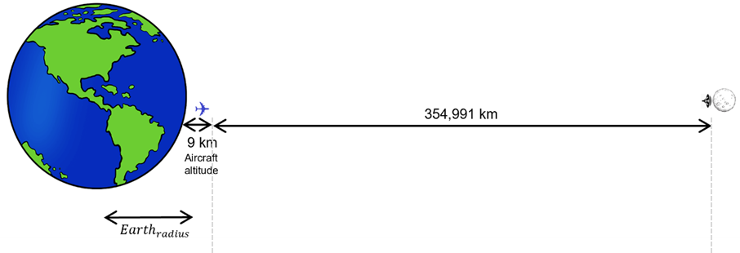
(b)
Table A.2.2.1.3
SRS – RLS co-channel results
SRS Station | SRS center frequency | Radar | Analysis | I/N result | Margin to the radar protection criteria
Lunar Surface Transmitter | 425 MHz | Ground | Single Entry | -16.4 dB | 10.4 dB
Lunar Surface Transmitter | 425 MHz | Airborne | Single Entry | –35.4 dB | 29.4 dB
Lunar Surface Transmitter | 425 MHz | Shipborne | Single Entry | –26.4 dB | 20.4 dB

A.2.2.1.6 Summary and analysis of the results of Study A
The results of this study suggest that sharing between SRS and radars operating in the radiolocation service in the 420-430 MHz band (co-channel) is feasible. Furthermore, the interference-to-noise ratio metric shows that in the static worst-case analysis for a single interferer, there is a margin of at least 10.4 dB to satisfy the radiolocation service protection criteria.

A2.3 …

A2.[X] Summary and analysis of the results of studies
[Note: The summary should offer an objective overview, encompassing the results of sharing and compatibility studies, alongside any pertinent information applicable for future comparisons among studies. Additionally, it should address any mitigation techniques or proposals employed to safeguard services operating within the same band or adjacent bands, where applicable, to SRS lunar systems.]

ANNEX 3
Sharing and compatibility studies of SRS for lunar operations
in the frequency band 440-450 MHz

A3.1 Sharing studies between fixed services and SRS operating in the frequency band 440-450 MHz

A3.1.1 Study A [USA]

A.3.1.1.1 Technical and operational characteristics of SRS operating in the 440-450 MHz frequency range
The technical and operational characteristics for SRS systems are based on those available in the preliminary draft of the new report ITU-R SA.[LUNAR.SRS STATIONS CHAR], including Table 3.2-4, as summarized in Table A.2.1.1.1.
Table A.3.1.1.1
Technical Characteristics of the SRS Systems
Station | Lunar Surface-to-Surface Transmitter
Frequency range | 440-450 MHz
Beam Type | Fixed
Polarization | Vertical
Peak Gain (dBi) | 0.0
Max. EIRP Density (dBW/Hz) | ‒61
Max. EIRP (dBW) | 2
Antenna Height | < 5 m
Channel BW (MHz) | 2

A.3.1.1.2 Technical and operational characteristics of fixed service operating in the 440– 450 MHz frequency range
The Document 7B/56 provides relevant technical information to support studies between SRS and Fixed Services (FS) under agenda item 1.15. The characteristics for fixed service (FS) for point-to-point (PP) systems are based on the information contained in the draft revision of Recommendation ITU-R F.758-7, Table 17, as summarized in Table A.3.1.1.2.
Table A.3.1.1.2
Characteristics of the FS (PP) systems
Parameter | Value
Frequency range | 406.1-450 MHz
Reference | Recommendation ITU-R F.1567
Modulation format | 32-QAM
Receiver noise bandwidth | 3.5 MHz
Antenna height | 30 m
Antenna pattern | Recommendation ITU-R F.699
Antenna gain | 25 dBi
Feeder loss | 2 dB
Receiver noise figure | 3.5 dB
Protection criteria (I/N) | ‒6 dB

A.3.1.1.3 Propagation model
This sharing study includes the lunar SRS system on the surface of the Moon and fixed services operating on Earth's surface. Therefore, Working Party 3J in the Document 7B/58 recommends using the propagation model based on Recommendation ITU-R P.525 for this scenario.

A.3.1.1.4 Methodology
The methodology employed in this study is based on a static analysis of both single and aggregated worst-case interference. It evaluates whether, even under conditions of perfect antenna coupling between the systems, at the minimum distance between the stations on Earth and the Moon, and in the absence of antenna pointing errors and losses such as depolarization and clutter, the interference levels comply with the established ITU-R service protection criteria.

A.3.1.1.5 Study Results
The study was conducted in accordance with the scenario outlined in Figure A.2.1.1.1. For the worst-case analysis, the following assumptions were considered:
– Main beam antenna coupling between the potentially interfering lunar SRS transmitters and the FS victim receiver.
– Free space propagation loss assuming the minimum distance between the stations on the Earth and the Moon (355,000 km), while atmospheric, depolarization and clutter losses are not considered.
– The aggregate interference-to-noise ratio (I/N) is calculated considering Lunar SRS transmitters pointing towards the FS victim receiver using the following equation:
$${\left(\frac{I}{N}\right)}_{Total}= \sum_{1}^{n}{{ ({EIRP}_{n}}_{θ,φ}-FSPL-F_{loss}+{G_{rx}}_{θ,φ})-N_{rx}}$$
where n is the number of lunar surface transmitters; ${ {EIRP}_{n}}_{θ,φ}$is the equivalent isotropic radiated power of each lunar transmitter; FSPL is the free space path loss calculated using Recommendation ITU-R P.525; $F_{loss}$ is the FS feeder loss; ${{(G}_{rx})}_{θ,φ}$is the FS victim receiver maximum antenna gain; and $N_{rx}$ is the thermal noise power in the FS victim receiver bandwidth.
– The receiver thermal noise power is calculated from the receiver noise figure (NF) using the formula provided in Recommendation ITU-R P.372-17.
– The single and aggregate I/N results are compared to the FS protection criteria (I/N ≤ −6 dB) to verify whether the FS protection is met.
Figure A.2.1.1.1
SRS – FS Scenario
Table A.2.1.1.3
SRS - FS co-channel results
SRS Station | SRS center frequency | Analysis | I/N result | Margin to the FS protection criteria
Lunar Surface Transmitter | 425 MHz | Single Entry | −36.3 dB | 30.6 dB

A.3.1.1.6 Summary and analysis of the results of Study A
The results of this study suggest that sharing between SRS and ground-based FS operating in the 440-450 MHz band (co-channel) is feasible. The interference-to-noise ratio metric shows that even in the single entry static worst-case analysis, there is a margin of at least 30.6 dB to satisfy the FS protection criteria. That also implies that aggregating over 1100 worst case interfering transmitters would still meet the FS protection criteria, which far exceeds the expected number of lunar transmitters in this band.

A3.1.2 Study B

A3.1.3 Study C

A3.2 Sharing studies between radiolocation service and SRS operating in the frequency band 440-450 MHz

A2.2.1 Study A [USA]

A.2.2.1.1 Technical and operational characteristics of SRS operating in the 440-450 MHz frequency range
The technical and operational characteristics for SRS systems are based on those available in the preliminary draft of the new report ITU-R SA.[LUNAR.SRS STATIONS CHAR], including Table 3.2-4, as summarized in Table A.2.2.1.1.
Table A.2.2.1.1
Technical Characteristics of the SRS Systems
Station | Lunar Surface-to-Surface Transmitter
Frequency range | 440-450 MHz
Beam Type | Fixed
Polarization | Vertical
Peak Gain (dBi) | 0.0
Max. EIRP Density (dBW/Hz) | ‒61
Max. EIRP (dBW) | 2
Antenna Height | < 5 m
Channel BW (MHz) | 2

A.2.2.1.2 Technical and operational characteristics of radiolocation service operating in the 440-450 MHz frequency range
The Document 7B/114 provides relevant technical information to support studies between SRS and radars operating in the radiolocation service (RLS) under agenda item 1.15. The characteristics for radars systems are based on the Recommendation ITU-R F.1462-1, Tables 1, 3 and 4, as summarized in Table A.3.2.1.2.
Table A.3.2.1.2
Characteristics of the radar systems
Parameter | Ground | Airborne | Shipborne
Frequency range | 420- 450 MHz
Polarization | Circular | Horizontal | -
Platform height/altitude | 15 m | Ascent, descent and operational operations. Ceiling is around 9 km | -
Antenna gain | 40 dBi | 22 dBi | 30 dBi
Antenna scan | Sector ±60° azimuth scan, with rotating or random modes 3-85° elevation | ±60° elevation (mechanically positioned or electronically scanned);  360⁰ azimuth at 3-7 rpm | 360⁰ azimuth
Receiver noise figure | 4 dB | 5 dB | 4 dB
Receiver IF bandwidth | 2 MHz | 1 MHz | 2 MHz
Protection criteria (I/N) | ‒6 dB

A.3.2.1.3 Propagation model
This sharing study includes the lunar SRS system on the surface of the Moon, and radiolocation service operating on Earth's surface. Therefore, Working Party 3J in Document 7B/58 recommends using the propagation model based on Recommendation ITU-R P.525 for this scenario.

A.3.2.1.4 Methodology
The methodology employed in this study is based on a static analysis of both single and aggregated worst-case interference. It evaluates whether, even under conditions of perfect antenna coupling between the systems, at the minimum distance between the stations on Earth and the Moon, and in the absence of antenna pointing errors and losses such as depolarization and clutter, the interference levels comply with the established ITU-R service protection criteria.

A.3.2.1.5 Study results
The study was conducted in accordance with the scenarios outlined in Figure A.3.2.1.1. For the worst-case analysis, the following assumptions were considered:
– Main beam antenna coupling between the potentially interfering lunar SRS transmitters and the radar victim receiver.
– Free space propagation loss assuming the minimum distance between the stations on the Earth and the Moon (355,000 km for ground and shipborne radars and 354,991 km for airborne), while atmospheric, depolarization and clutter losses are not considered.
– In the present study, it is assumed that both systems operate at the same central frequency. A bandwidth correction factor (CF) is applied when the bandwidth of the potential interferer exceeds the bandwidth of the victim receiver under analysis. If the bandwidth of the interferer is equal to or smaller than that of the victim receiver, the bandwidth correction factor is 0:
$$CF = 10 * \log_{10}\left(\frac{{bandwidth}_{victim}}{{bandwidth}_{interferer}}\right)$$
– The aggregate interference-to-noise ratio (I/N) is calculated considering three Lunar SRS transmitters pointing towards the radar victim receiver using the following equation:
$${\left(\frac{I}{N}\right)}_{Total}= \sum_{1}^{n}{{ ({EIRP}_{n}}_{θ,φ}+CF-FSPL+{G_{rx}}_{θ,φ})-N_{rx})}$$
where n is the number of lunar surface transmitters; ${ {EIRP}_{n}}_{θ,φ}$is the equivalent isotropic radiated power of each lunar transmitter; FSPL is the free space path loss calculated using Rec. ITU-R P.525; ${{(G}_{rx})}_{θ,φ}$is the radar victim receiver maximum antenna gain; and $N_{rx}$ is the thermal noise power in the radar victim receiver bandwidth.
– The receiver thermal noise power is calculated from the receiver noise figure (NF) using the formula provided in Recommendation ITU-R P.372-17.
– The single and aggregate I/N results are compared to the radar protection criteria (I/N ≤ −6 dB) to verify whether the radiolocation service protection is met.
Figure A.3.2.1.1
SRS–RLS Scenarios: (a) Ground and shipborne; (b) Airborne
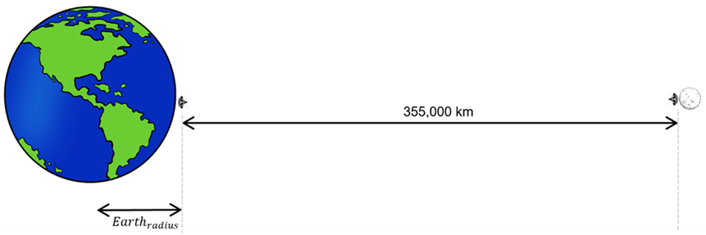
(a)
(b)
Table A.3.2.1.3
SRS – RLS co-channel results
SRS Station | SRS center frequency | Radar | Analysis | I/N result | Margin to the radar protection criteria
Lunar Surface Transmitter | 445 MHz | Ground | Single Entry | -17.3 dB | 11.3 dB
Lunar Surface Transmitter | 445 MHz | Airborne | Single Entry | -36.3 dB | 30.3 dB
Lunar Surface Transmitter | 445 MHz | Shipborne | Single Entry | -27.4 dB | 21.5 dB

A.3.2.1.6 Summary and analysis of the results of Study A
The results of this study suggest that sharing between SRS and radars operating in the radiolocation service in the 440-450 MHz band (co-channel) is feasible. Furthermore, the interference-to-noise ratio metric shows that in the static worst-case analysis for a single potential interferer, there is a margin of at least 11.3 dB to satisfy the radiolocation service protection criteria.

A3.3 …

A3.[X] Summary and analysis of the results of studies
[Note: The summary should offer an objective overview, encompassing the results of sharing and compatibility studies, alongside any pertinent information applicable for future comparisons among studies. Additionally, it should address any mitigation techniques or proposals employed to safeguard services operating within the same band or adjacent bands, where applicable, to SRS lunar systems.]
ANNEX 4
Sharing and compatibility studies of SRS for lunar operations
in the frequency band 2 400-2 690 MHz
[Note: Insert relevant sharing and compatibility studies for each of the identified service.]

A4.1 Sharing studies between fixed services and SRS for lunar operations in the frequency band 2 400-2 690 MHz

A4.1.1 Study A [USA]

A.4.1.1.1 Technical and operational characteristics of SRS operating in the 2 400-2 690 MHz frequency range
The technical and operational characteristics for SRS systems are based on those available in the preliminary draft of the new report ITU-R SA.[LUNAR.SRS STATIONS CHAR], including Table 3.2-4, as summarized in Table A.4.1.1.1.
Table A.4.1.1.1
Technical Characteristics of the SRS Systems
Station | Lunar Surface-to-Surface Transmitter
Frequency range | 2 400-2 483.5 MHz | 2 500-2 690 MHz
Polarization | Vertical | Linear ±45º
Peak Gain (dBi) | 7 | 16
EIRP Density (dBW/MHz) | 19 | 19
Max. EIRP (dBW) | 6 | 29
Channel BW (MHz) | 20 | 10

A.4.1.1.2 Technical and operational characteristics of fixed service operating in the 2 400-2 690 MHz frequency range
The Document 7B/56 provides relevant technical information to support studies between SRS and Fixed Services (FS) under agenda item 1.15. The characteristics for fixed service (FS) for point-to-point (PP) and point-to-multipoint (PmP) systems are based on the information contained in the draft revision of Recommendation ITU-R F.758-7, Tables 17 and 20, as summarized in Table A.4.1.1.2.
Table A.4.1.1.2
Characteristics of the FS systems
Parameter | Point-to-point (PP) | Point-to-multipoint (PmP)
Frequency range | 2290-2670 MHz | 1350-2690 MHz
Reference | Recommendation ITU-R F.1243 | Recommendation ITU-R F.701
Modulation format | MSK | QPSK
Receiver noise bandwidth | 14 MHz | 3.5 MHz
Antenna height | 50 m | 30 m
Antenna pattern | Recommendation ITU-R F.699 | Recommendation ITU-R F.699
Antenna gain | 25 dBi | 27 dBi
Feeder loss | 4 dB | 0 dB
Receiver noise figure | 4 dB | 3.5 dB
Protection criteria (I/N) | -6 dB

A.4.1.1.3 Propagation model
This study includes the lunar SRS system orbiting the Moon and fixed services operating on Earth's surface. Therefore, Working Party 3J in the Document 7B/58 recommends using the propagation model based on Recommendation ITU-R P.525 for this scenario.

A.4.1.1.4 Methodology
The methodology employed in this study is based on a static analysis of both single and aggregated worst-case interference. It evaluates whether, even under conditions of perfect antenna coupling between the systems, at the minimum distance between the stations on Earth and the Moon, and in the absence of antenna pointing errors and losses such as depolarization and clutter, the interference levels comply with the established ITU-R service protection criteria.

A.4.1.1.5 Study Results
The study was conducted in accordance with the scenario outlined in Figure A.4.1.1.1. For the worst-case analysis, the following assumptions were considered:
– Main beam antenna coupling between the potentially interfering lunar SRS transmitters and the FS victim receiver.
– Free space propagation loss assuming the minimum distance between the stations on the Earth and the Moon (355,000 km), while atmospheric, depolarization and clutter losses are not considered.
– In the present study, it is assumed that both systems operate at the same central frequency. A bandwidth correction factor (CF) is applied when the bandwidth of the potential interferer exceeds the bandwidth of the victim receiver under analysis. If the bandwidth of the interferer is equal to or smaller than that of the victim receiver, the bandwidth correction factor is 0:
$$CF = 10 * \log_{10}\left(\frac{{bandwidth}_{victim}}{{bandwidth}_{interferer}}\right)$$
– The aggregate interference-to-noise ratio (I/N) is calculated considering Lunar SRS transmitters pointing towards the FS victim receiver using the following equation:
$${\left(\frac{I}{N}\right)}_{Total}= \sum_{1}^{n}{{ ({EIRP}_{n}}_{θ,φ}+CF-FSPL-F_{loss}+{G_{rx}}_{θ,φ})-N_{rx})}$$
where n is the number of lunar surface transmitters; ${ {EIRP}_{n}}_{θ,φ}$is the equivalent isotropic radiated power of each lunar transmitter; FSPL is the free space path loss calculated using Recommendation ITU-R P.525; $F_{loss}$ is the FS feeder loss; ${{(G}_{rx})}_{θ,φ}$is the FS victim receiver maximum antenna gain; and $N_{rx}$ is the thermal noise power in the FS victim receiver bandwidth.
– The receiver thermal noise power is calculated from the receiver noise figure (NF) using the formula provided in Recommendation ITU-R P.372-17.
– The single and aggregate I/N results are compared to the FS protection criteria (I/N ≤ −6 dB) to verify whether the FS protection is met.
Figure A.4.1.1.1
SRS–FS Scenario
Table A.4.1.1.3
SRS – FS (PP) co-channel results
SRS Station | SRS center frequency | Analysis | I/N result | Margin to the FS protection criteria
Lunar Surface Transmitter | 2 410 MHz | Single Entry | –57.0 dB | 51.0 dB
Lunar Surface Transmitter | 2 510 MHz | Single Entry | –32.8 dB | 26.8 dB
Table A.4.1.1.4
SRS – FS (PmP) co-channel results
SRS Station | SRS center frequency | Analysis | I/N result | Margin to the FS protection criteria
Lunar Surface Transmitter | 2 410 MHz | Single Entry | –50.5 dB | 44.5 dB
Lunar Surface Transmitter | 2 510 MHz | Single Entry | –24.9 dB | 18.9 dB

A.4.1.1.6 Conclusion of Study A
The interference-to-noise ratio metric shows that in the single entry static worst-case analysis, there is a margin of at least 18.9 dB to satisfy the FS protection criteria.
[USA Note: An updated analysis will include the aggregate impact of lunar emissions.]

A4.1.2 Study B

A4.1.3 Study C

A4.2 Sharing studies between mobile service operating as a terrestrial component of IMT and SRS operating in the frequency band 2 400-2 690 MHz

A4.2.1 Study A [USA]

A.4.2.1.1 Technical and operational characteristics of SRS operating in the 2500-2690 MHz frequency range
The technical and operational characteristics for SRS systems are based on those available in the preliminary draft of the new report ITU-R SA.[LUNAR.SRS STATIONS CHAR], including table 3.2-4, as summarized in Table A.4.2.1.1.
Table A.4.2.1.1
Technical Characteristics of the SRS Systems
Station | Lunar Surface-to-Surface Transmitter
Frequency range | 2 500-2 690 MHz
Polarization | Linear ±45º
Peak Gain (dBi) | 16
EIRP Density (dBW/MHz) | 19
Max. EIRP (dBW) | 29
Channel BW (MHz) | 10

A.4.2.1.2 Technical and operational characteristics of mobile service operating as a terrestrial component of IMT in the 2500-2690 MHz frequency range
The Document 7B/105 provides relevant technical information to support studies between SRS and mobile services operating as a terrestrial component of IMT, under agenda item 1.15. The characteristics and protection criteria for terrestrial component of IMT are based on the information contained in the Annex 4.4 to Document 5D/716, as summarized in Tables A.4.2.1.2 and A.4.2.1.3.
Table A.4.2.1.2
IMT Base Station (BS) parameters for bands between 2 and 3 GHz
 | Rural/ Urban/suburban macro
Antenna height | 30 m rural /20 m urban /25 m suburban
AAS Antenna gain | 26.2 dBi
AAS BS antenna polarization | Linear ±45 degrees
Channel bandwidth | 10 MHz
AAS BS Noise Figure | 5 dB
Table A.4.2.1.3
IMT User Equipment (UE) parameters for bands between 2 and 3 GHz
 | Rural/Urban/suburban macro
UE height | 1.5 m
Typical antenna gain | −3 dBi
Body loss | 4 dB
UE Noise Figure | 9 dB

For this study, the AAS rural/urban/suburban macro scenario represents the worst case, as the base station antenna gain is higher than in non-AAS case.

A.4.2.1.3 Propagation model
This sharing study includes the lunar SRS system on the surface of the Moon, and mobile services operating on Earth's surface. Therefore, Working Party 3J in Document 7B/58 recommends using the propagation model based on Recommendation ITU-R P.525 for this scenario.

A.4.2.1.4 Methodology
The methodology employed in this study is based on a static analysis of both single and aggregated worst-case interference. It evaluates whether, even under conditions of perfect antenna coupling between the systems, at the minimum distance between the stations on Earth and the Moon, and in the absence of antenna pointing errors and losses such as depolarization, body, building and clutter, the interference levels comply with the established ITU-R service protection criteria.
The study also considered the IMT network in TDD to examine the lower frequencies for both base stations and user equipment. However, no TDD factor was applied in this analysis to compute the interference received by the base station and user equipment 100% of the time, in order to verify compliance with the established ITU-R service protection criteria, even in the worst-case scenario.

A.4.2.1.5 Study results
The study was conducted in accordance with the scenario outlined in Figure A.4.2.1.1. For the worst-case analysis, the following assumptions were considered:
– Main beam antenna coupling between the potentially interfering lunar SRS transmitters and the IMT victim receiver.
– Free space propagation loss assuming the minimum distance between the stations on the Earth and the Moon (355,000 km), while atmospheric, depolarization and clutter losses are not considered.
– The aggregate interference-to-noise ratio (I/N) is calculated considering Lunar SRS transmitters pointing towards the IMT victim receiver using the following equation:
$${\left(\frac{I}{N}\right)}_{Total}= \sum_{1}^{n}{{ ({EIRP}_{n}}_{θ,φ}-FSPL+{G_{rx}}_{θ,φ})-N_{rx})}$$
where n is the number of lunar surface transmitters; ${ {EIRP}_{n}}_{θ,φ}$is the equivalent isotropic radiated power of each lunar transmitter; FSPL is the free space path loss calculated using Rec. ITU-R P.525; ${{(G}_{rx})}_{θ,φ}$is the IMT victim receiver maximum antenna gain; and $N_{rx}$ is the thermal noise power in the IMT victim receiver bandwidth.
– The receiver thermal noise power is calculated from the receiver noise figure (NF) using the formula provided in Recommendation ITU-R P.372-17.
– The worst case aggregate static interference is calculated based on the lunar surface deployment characteristics provided in PDN Report ITU-R SA.[LUNAR.SRS STATIONS CHAR]. Notably the lunar surface deployment in the 2 500 – 2690 MHz band assumes 1-3 LCT base stations per cluster with up to 10 clusters located on the Moon and a network activity factor of 50%. Assuming that roughly half of the clusters will be visible to Earth, then the aggregate static interference calculation assumes that up to 8 LCT base station transmitters could be active simultaneously.
– The single and aggregate I/N results are compared to the IMT protection criteria (I/N ≤ −6 dB) to verify whether the IMT protection is met.
Figure A.4.2.1.1
SRS–IMT Scenario
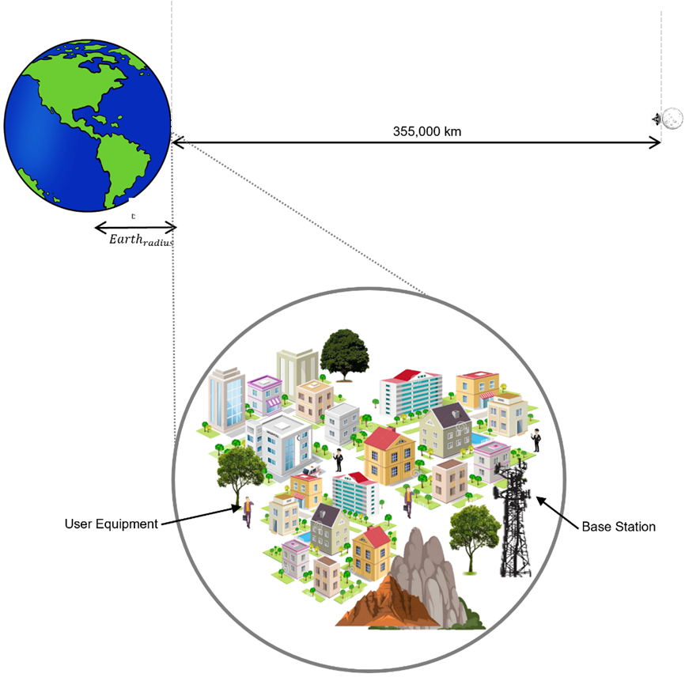
Table A.4.2.1.4
SRS – IMT co-channel results
SRS Station | SRS center frequency | IMT Station | Analysis | I/N result | Margin to the IMT protection criteria
Lunar Surface Transmitter | 2 510 MHz | Base Station | Single Entry | –27.2 dB | 21.2 dB
Lunar Surface Transmitter | 2 510 MHz | Base Station | Aggregate | -18.2 dB | 12. 2 dB
Lunar Surface Transmitter | 2 510 MHz | User Equipment | Single Entry | –60.4 dB | 54.4 dB
Lunar Surface Transmitter | 2 510 MHz | User Equipment | Aggregate | -51.4 dB | 45.4 dB

A.4.2.1.6 Summary and analysis of the results of Study A
The interference-to-noise ratio metric shows that in the single entry static worst-case analysis, there is a margin of at least 21.2 dB to satisfy the IMT Base Station protection criteria and 54.4 dB to satisfy the IMT User Equipment (UE) protection criterion. For the aggregate worst case analysis, the interference margin is 12.2 dB for the IMT Base Station and 45.4 dB for the IMT UE.

A4.3 Sharing studies between mobile satellite service (MSS) and SRS operating in the frequency band 2 483.5-2 500 MHz

A4.3.1 Study A [USA]

A.4.3.1.1 Technical and operational characteristics of SRS operating in the 2483.5-2500 MHz frequency range
The technical and operational characteristics for SRS systems are based on those available in the preliminary draft of the new report ITU-R SA.[LUNAR.SRS STATIONS CHAR], including Table 3.3-4, as summarized in Table A.4.3.1.1.
Table A.4.3.1.1
Technical Characteristics of the SRS Systems
Station | Lunar Orbit Space Station Transmitter
Frequency range | 2 483.5-2 500 MHz
Polarization | CP
Peak Gain (dBi) | 16
Max EIRP Density (dBW/Hz) | -48
Max. EIRP (dBW) | 24
Orbital Characteristics  Apolune (km)  Perilune (km) | 7 000-11 000  600-2 700
Channel BW (MHz) | 16

A.4.3.1.2 Technical and operational characteristics of Mobile Satellite Service (MSS) operating in the 2 483.5-2 500 MHz frequency range
The Document 7B/106 provides relevant technical information to support studies between SRS and Mobile Satellite Service (MSS) (space-to-Earth) under agenda item 1.15, with the characteristics and protection criteria summarized in Table A.4.3.1.2.
Table A.4.3.1.2
MSS (space-to-Earth) receiver characteristics in 2 483.5-2 500 MHz
 | System 1  (HIBLEO-X) | System 2
Height of receivers | 1.5 m | 1.5 m
Centre frequency | 2 484.39 MHz | 2 485.75 MHz
Bandwidth | 1.23 MHz | 4.5 MHz
Terminal noise temperature | N = −113.9 dBm/MHz | N = −100.9 dBm/MHz
Antenna gain | 2.4 dBi | −1 dBi
Protection criteria (I/N) | −10 dB | −10 dB
Location | Suburban / Rural | Suburban / Rural

A.4.3.1.3 Propagation model
This sharing study includes the lunar SRS system in orbit of the Moon, and MSS operating on Earth's surface. Therefore, Working Party 3J in Document 7B/58 recommends using the propagation model based on Recommendation ITU-R P.525 for this scenario.

A.4.3.1.4 Methodology
The methodology employed in this study is based on a static analysis of both single and aggregated worst-case interference. It evaluates whether, even under conditions of perfect antenna coupling between the systems, at the minimum distance between the stations on Earth and the Moon, and in the absence of antenna pointing errors and losses such as depolarization and clutter, the interference levels comply with the established ITU-R service protection criteria.

A.4.3.1.5 Study results
The study was conducted in accordance with the scenario outlined in Figure A.4.3.1.1. For the worst-case analysis, the following assumptions were considered:
– Main beam antenna coupling between the potentially interfering lunar SRS transmitters and the MSS victim receiver.
– Free space propagation loss assuming the minimum distance between the stations on the Earth and the Moon (355,000 km), while atmospheric, depolarization and clutter losses are not considered.
– In the present study, it is assumed that both systems operate at the same central frequency. A bandwidth correction factor (CF) is applied when the bandwidth of the potential interferer exceeds the bandwidth of the victim receiver under analysis. If the bandwidth of the interferer is equal to or smaller than that of the victim receiver, the bandwidth correction factor is 0:
$$CF = 10 * \log_{10}\left(\frac{{bandwidth}_{victim}}{{bandwidth}_{interferer}}\right)$$
– The aggregate interference-to-noise ratio (I/N) is calculated considering Lunar SRS transmitters pointing towards the MSS victim receiver using the following equation:
$${\left(\frac{I}{N}\right)}_{Total}= \sum_{1}^{n}{{ ({EIRP}_{n}}_{θ,φ}+CF-FSPL+{G_{rx}}_{θ,φ})-N_{rx})}$$
where n is the number of lunar surface transmitters; ${ {EIRP}_{n}}_{θ,φ}$is the equivalent isotropic radiated power of each lunar transmitter; FSPL is the free space path loss calculated using Rec. ITU-R P.525; ${{(G}_{rx})}_{θ,φ}$is the MSS victim receiver maximum antenna gain; and $N_{rx}$ is the thermal noise power in the MSS victim receiver bandwidth
– The receiver thermal noise power is calculated from the receiver noise figure (NF) using the formula provided in Recommendation ITU-R P.372-17.
– The single and aggregate I/N results are compared to the MSS protection criteria (I/N ≤ −10 dB) to verify whether the MSS protection is met.
Figure A.4.3.1.1
SRS–MSS (space-to-Earth) Scenario
Table A.4.3.1.3
SRS – MSS (space-to-Earth) co-channel results
SRS Station | SRS center frequency | MSS Station | Analysis | I/N result | Margin to the MSS protection criteria
Lunar Orbit Space Transmitter | 2 491.75 MHz | System 1 | Single Entry | –53.0 dB | 43.0 dB
Lunar Orbit Space Transmitter | 2 491.75 MHz | System 2 | Single Entry | –69.4 dB | 59.4 dB

A.4.3.1.6 Summary and analysis of the results of Study A
The results of this study suggest that sharing between SRS and MSS (space-to-Earth) operating in the 2 483.5-2 500 MHz band (co-channel), is feasible. The interference-to-noise ratio metric shows that in the single entry static worst-case analysis, there is a margin of at least 43 dB to satisfy the MSS protection criteria. This implies that the aggregate interference from 19 952 lunar transmitters would not exceed the MSS protection criterion in this band.

A4.4 Sharing studies between high-altitude platform stations as IMT base stations (HIBS) and SRS operating in the frequency band 2 500-2 690 MHz

A4.4.1 Study A [USA]

A.4.4.1.1 Technical and operational characteristics of SRS operating in the 2 500-2 690 MHz frequency range
The technical and operational characteristics for SRS systems are based on those available in the preliminary draft of the new report ITU-R SA.[LUNAR.SRS STATIONS CHAR], including Table 3.2-4, as summarized in Table A.4.4.1.1.
Table A.4.4.1.1
Technical Characteristics of the SRS Systems
Station | Lunar Surface-to-Surface Transmitter
Frequency range | 2 500-2 690 MHz
Polarization | Linear ±45º
Peak Gain (dBi) | 16
EIRP Density (dBW/MHz) | 19
Max. EIRP (dBW) | 29
Channel BW (MHz) | 10

A.4.4.1.2 Technical and operational characteristics of high-altitude platform stations as IMT base stations (HIBS) in the 2500-2690 MHz frequency range
The Document 7B/64 provides the characteristics and protection criteria to support studies between SRS and HIBS under agenda item 1.15. The technical and operational characteristics are summarized in Table A.4.4.1.2.
Table A.4.4.1.2
Specification and deployment related parameters of HIBS
Parameter | Band 3 (2 500-2 690 MHz)
Duplex method and transmission direction | FDD/TDD (as per frequency arrangements in  Recommendation ITU-R M.1036)
Channel bandwidth (MHz) | 20 MHz
HIBS Platform Altitude | 18-25 km
Number of cells/HIBS | 7
Antenna gain | 14 dBi (1st layer cell), 17 dBi (2nd layer cell)
Noise Figure | 5 dB
Protection criteria (I/N) | −6 dB

A.4.4.1.3 Propagation model
This sharing study includes the lunar SRS system on the surface of the Moon, and HIBS operating on Earth's surface. Therefore, Working Party 3J in Document 7B/58 recommends using the propagation model based on Recommendation ITU-R P.525 for this scenario.

A.4.4.1.4 Methodology
The methodology employed in this study is based on a static analysis of both single and aggregated worst-case interference. It evaluates whether, even under conditions of perfect antenna coupling between the systems, at the minimum distance between the stations on Earth and the Moon, and in the absence of antenna pointing errors and losses such as depolarization and atmospheric, the interference levels comply with the established ITU-R service protection criteria.

A.4.4.1.5 Study results
The study was conducted in accordance with the scenario outlined in Figure A.4.4.1.1. For the worst-case analysis, the following assumptions were considered:
– Main beam antenna coupling between the potentially interfering lunar SRS transmitters and the HIBS victim receiver.
– For the HIBS victim receiver, the highest antenna gain of 17 dBi was considered, which corresponds to the second-layer cell.
– Free space propagation loss assuming the minimum distance between the stations on the Earth and the Moon (354,975 km), while atmospheric and depolarization and are not considered.
– The aggregate interference-to-noise ratio (I/N) is calculated considering Lunar SRS transmitters pointing towards the HIBS victim receiver using the following equation:
$${\left(\frac{I}{N}\right)}_{Total}= \sum_{1}^{n}{{ ({EIRP}_{n}}_{θ,φ}-FSPL+{G_{rx}}_{θ,φ})-N_{rx})}$$
where n is the number of lunar surface transmitters; ${ {EIRP}_{n}}_{θ,φ}$is the equivalent isotropic radiated power of each lunar transmitter; FSPL is the free space path loss calculated using Rec. ITU-R P.525; ${{(G}_{rx})}_{θ,φ}$is the HIBS victim receiver maximum antenna gain; and $N_{rx}$ is the thermal noise power in the HIBS victim receiver bandwidth.
– The receiver thermal noise power is calculated from the receiver noise figure (NF) using the formula provided in Recommendation ITU-R P.372-17.
– The single and aggregate I/N results are compared to the HIBS protection criteria (I/N ≤ −6 dB) to verify whether the HIBS protection is met.
Figure A.4.4.1.1
SRS–HIBS Scenario
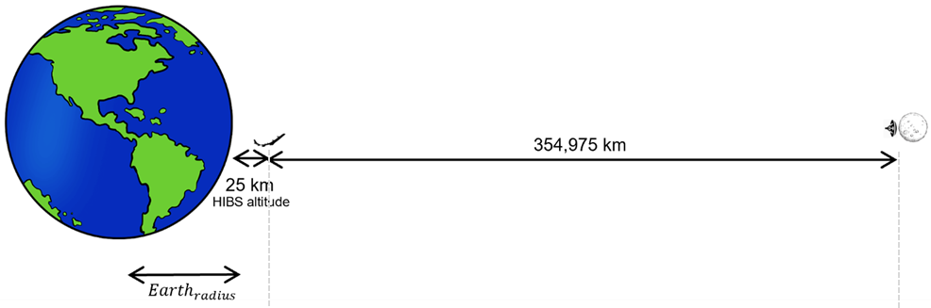
Table A.4.4.1.3
SRS – HIBS co-channel results
SRS Station | SRS center frequency | Analysis | I/N result | Margin to the HIBS protection criteria
Lunar Surface Transmitter | 2520 MHz | Single Entry | −39.4 dB | 33.4 dB

A.4.4.1.6 Summary and analysis of the results of Study A
The results of this study suggest that sharing between SRS and HIBS in the 2500-2690 MHz band (co-channel), is feasible. The interference-to-noise ratio metric shows that in the single entry static worst-case analysis, there is a margin of at least 33.4 dB to satisfy the HIBS protection criteria. This implies that the aggregate interference from 2187 worst case lunar transmitters would not exceed the HIBS protection criterion in this band.

A4.5 Compatibility studies between aeronautical radionavigation service (ARNS) operating in the frequency band 2 700-2900 MHz and SRS operating in the frequency band 2 500-2 690 MHz

A4.5.1 Study A
This study shows the static worst case interference analysis for adjacent band compatibility between ARNS in 2 700 – 2 900 MHz and lunar surface SRS in the frequency band 2500-2690 MHz.

A4.5.1.1 Lunar SRS Unwanted Emissions
Due to the 10 MHz frequency separation between the ARNS and lunar SRS bands, the spurious emissions limit for 3GPP stations is assumed. Thus the unwanted emissions level for the lunar SRS transmitter in 2 700 – 2 900 MHz used in this analysis is -13 dBm/MHz.

A4.5.1.2 ARNS radar characteristics
The characteristics of different types of ARNS radars in 2 700 – 2 900 is found in Recommendation ITU-R M.1464-2, and a summary of some of the relevant parameters is given in the table below. A protection criteria of -10 dB I/N for the ARNS radars is used in this analysis.
Table. Characteristics of ARNS radars in frequency band 2 700 – 2 900 MHz
 | Radar A | Radar B | Radar C | Radar D | Radar E | Radar F
Transmit power into antenna (kW) | 1400 | 1320 | 25 | 450 | 22 | 70
Antenna main beam gain (dBi) | 33.5 | 33.5 | 34 | 32.8 | 34.3 | 33.5
Receiver bandwidth (MHz) | 13 | 0.7 | 1.1 |  | 1.2 | 4
Receiver noise figure (dB) | 4 | 4 | 3.3 | 2.7 | 2.1 | 2

A4.5.1.3 Study results
A summary of the I/N results for the ARNS receiver using worst case static analysis is given in Table 2 below. Due to the Moon-Earth distance and the spurious emissions limit for the lunar SRS transmitter, the calculated interference is significantly lower than the protection criterion of -10 dB I/N.

Table. Summary of Lunar SRS-ARNS interference results in 2700-2900 MHz
 | Radar A | Radar B | Radar C | Radar D | Radar E | Radar F
I/N (dB) | -66.5 | -66.5 | -66.3 | -65.9 | -63.8 | -64.5
Protection Criteria (dB) | -10 | -10 | -10 | -10 | -10 | -10
Interference Margin (dB) | 56.5 | 56.5 | 56.3 | 55.9 | 53.8 | 54.5

A4.5.1 Summary and analysis of the results of Study A

[TBD]

A4.[X] Summary and analysis of the results of studies
[Note: The summary should offer an objective overview, encompassing the results of sharing and compatibility studies, alongside any pertinent information applicable for future comparisons among studies. Additionally, it should address any mitigation techniques or proposals employed to safeguard services operating within the same band or adjacent bands, where applicable, to SRS lunar systems.]

ANNEX 5
Sharing and compatibility studies of SRS for lunar operations
in the frequency band 3 500-3 800 MHz

A5.1 Sharing and compatibility of fixed service and SRS for lunar operations in the frequency band 3 500-3 800 MHz
[Note: Insert relevant sharing and compatibility studies for each of the identified service.]

A5.1.1 Study A [USA]

A.5.1.1.1 Technical and operational characteristics of SRS operating in the 3500-3800 MHz frequency range
The technical and operational characteristics for SRS systems are based on those available in the preliminary draft of the new report ITU-R SA.[LUNAR.SRS STATIONS CHAR], including table 3.2-4, as summarized in Table A.5.1.1.1.
Table A.5.1.1.1
Technical Characteristics of the SRS Systems
Station | Lunar Surface-to-Surface Transmitter
Frequency range | 3500 – 3800 MHz
Polarization | Linear ±45º
Peak Gain (dBi) | 26.2
EIRP Density (dBW/MHz) | 22.3
Max. EIRP (dBW) | 42.3
Channel BW (MHz) | 100 MHz

A.5.1.1.2 Technical and operational characteristics of fixed service operating in the 3500– 3800 MHz frequency range
Document 7B/56 provides relevant technical information to support studies between SRS and Fixed Services (FS) under agenda item 1.15. The characteristics for fixed service (FS) for point-to-point (PP) systems are based on the information contained in the draft revision of Recommendation ITU-R F.758-7, Table 18, as summarized in Table A.5.1.1.2.
Table A.5.1.1.2
Characteristics of the FS (PP) systems
Parameter | Value
Frequency range | 3600 - 4200 MHz
Reference | Recommendation ITU-R F.635
Modulation format | 64 QAM
Receiver noise bandwidth | 10 MHz
Antenna height | 30 m
Antenna pattern | Recommendation ITU-R F.699
Antenna gain | 42 dBi
Feeder loss | 0 dB
Receiver noise figure | 3 dB
Long Term Protection criteria (I/N) | ‒20 dB @ 20% percent of time  (Recommendation ITU-R F.758)

A.5.1.1.3 Propagation model
This sharing study includes the lunar SRS system on the surface of the Moon, and fixed services operating on Earth's surface. Therefore, Working Party 3J in Document 7B/58 recommends using the propagation model based on Recommendation ITU-R P.525 for this scenario.

A.5.1.1.4 Methodology
The methodology employed in this study is based on a dynamic analysis of single-entry interference. This analysis investigates the communication link between the SRS lunar transmitter, which may potentially cause interference in a FS PP receiver on Earth, and a receiver that could be an astronaut, lunar terrain vehicle, or lander. The SRS antenna pointing is varied across different elevation angles and azimuths, considering the location of the lunar receiver relative to the SRS lunar transmitter. The SRS lunar transmitter is positioned at the Moon's South Pole, a potential candidate location for NASA's Artemis Mission.

The analysis incorporates deployment considerations based on Recommendation ITU-R F.2086 for FS. The simulation accounts for the orbits of the Earth and Moon, utilizing the SPICE (Spacecraft, Planet, Instrument, C-matrix, Events) Kernel provided by the Navigation and Ancillary Information Facility (NAIF) at NASA’s Jet Propulsion Laboratory.

Considering orbital dynamics and system deployment characteristics, the simulation varies several parameters to compute the interference received by the FS receiver. The simulation spans a 5-year period, with a step size of 10 seconds, accounting for FS visibility to the Moon transmitter and potential antenna pointing configurations based on orbital dynamics. The complementary cumulative distribution function (CCDF) of interference over noise ratio (INR) is computed and compared with the protection criteria specified in ITU-R for FS. It is important to note that the simulation does not account for Earth or Moon terrain obstructions or clutter losses.

A.5.1.1.5 Study results
The study was conducted based on the assumptions below:
- The position of the SRS Lunar transmitter is at a latitude of -84.20156⁰ and a longitude of -60.69989⁰, as shown in Figure A.5.1.1.1, while the lunar receiver is positioned within a 360-degree azimuth range, at a maximum distance of 6 km from the transmitter
- The FS transmitter is located at a latitude of 34.03981⁰ and a longitude of -117.77210⁰, and the FS receiver is located at a latitude of 34.20101⁰ and a longitude of -118.17001⁰ as shown in Figure A.5.1.1.1
- The FS link distance is 40.5 km, the FS antenna height is 39 m, and the elevation angle is - 0.2 degrees, all within the range for FS deployment scenarios as specified in Recommendation ITU-R F.2086
- The FS antenna pattern is based on Recommendation ITU-R F.699, while the SRS Lunar transmitter antenna pattern is based on Radio Regulations Appendix 8, Annex 3.
- The SRS antenna elevation varies from 0 to -30 degrees, and the azimuth spans from 0 to 360 degrees, following the position of the lunar receiver. The antenna patterns are presented in Figure A.5.1.1.2
- In the present study, it is assumed that both systems operate at the same central frequency. A bandwidth correction factor (CF) is applied when the bandwidth of the potential interferer exceeds the bandwidth of the victim receiver under analysis. If the bandwidth of the interferer is equal to or smaller than that of the victim receiver, the bandwidth correction factor is 0
CF = 10 * log10bandwidthvictimbandwidthinterferer
- The interference-to-noise ratio (I/N) is calculated the following equation:
INTotal= 1n (EIRPnθ,φ+CF-FSPL-Floss+Grxθ,φ)-Nrx)
where n is the number of lunar surface transmitters; EIRPnθ,φ is the equivalent isotropic radiated power of each lunar transmitter towards the FS receiver; FSPL is the free space path loss calculated using Rec. ITU-R P.525; Floss is the FS feeder loss; (Grx)θ,φ is the FS victim receiver antenna gain in relation to the interferer; and Nrx is the thermal noise power in the FS victim receiver bandwidth
- The receiver thermal noise power is calculated from the receiver noise figure (NF) using the following equation:
N_{rx} = 10 log10 [k × (290 × 10^{(NF/10)}) × B]
where k is Boltzmann’s constant; B is the receiver bandwidth, and NF is the receiver noise figure in dB
- The I/N results are compared to the FS protection criteria (I/N ≤ 10 dB) to verify whether the FS protection is met
Figure A.5.1.1.1
SRS Transmitter- FS receiver positions
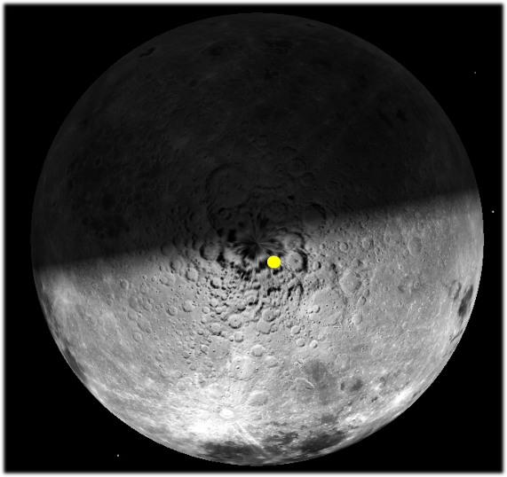 | 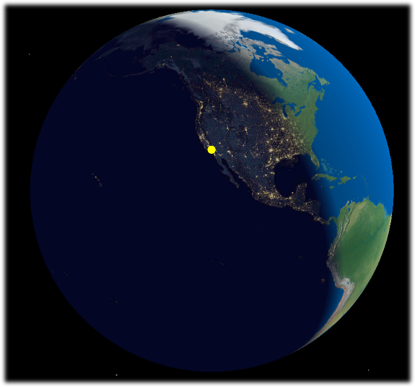

Figure A.5.1.1.2
Antenna patterns: (a) SRS; (b) FS:
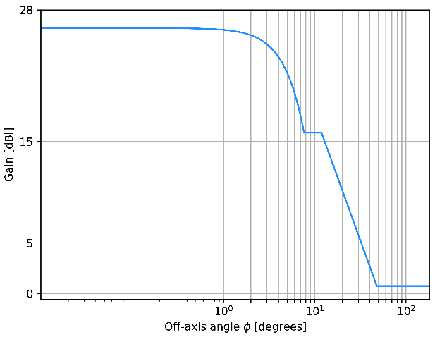 | 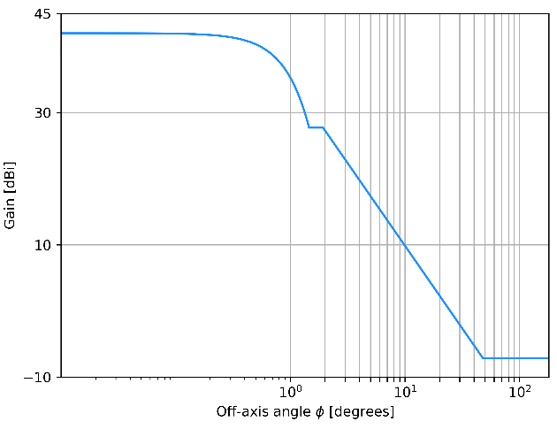
(a) | (b)

The study results are presented in the Complementary Cumulative Distribution Function (CCDF), which illustrates the probability that the interference-to-noise ratio (I/N) exceeds the FS protection criteria, as shown in Figure A.5.1.1.3. The maximum I/N value obtained was -16.9 dB, which occurs less than 0.0001% of the time.
Figure A.5.1.1.3
CCDF of I/N
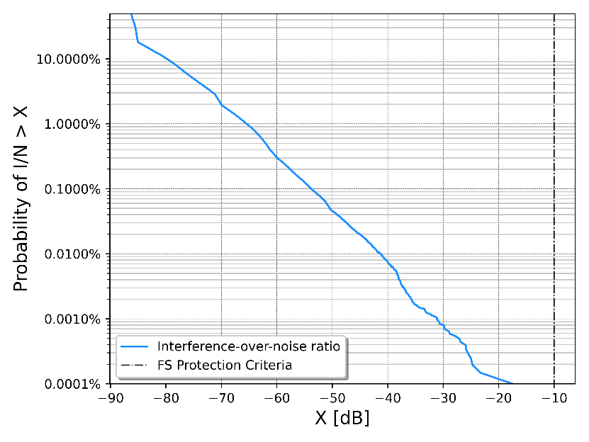

A.5.1.1.6 Summary and analysis of the results of Study A
The results of this study suggest that sharing between SRS and ground-based FS operating in the 3500-3800 MHz band (co-channel) is feasible. Furthermore, the interference-to-noise ratio metric shows that, in the dynamic analysis including single potential interferers, there is a margin of greater than 66 dB to the FS long term (20% of the time) protection criteria.

A5.1.2 Study B

A5.1.3 Study C

A5.2 Sharing studies between mobile service operating as a terrestrial component of IMT and SRS operating in the frequency band 3 500-3 800 MHz

A5.2.1 Study A [USA]

A.5.2.1.1 Technical and operational characteristics of SRS operating in the 3500-3800 MHz frequency range
The technical and operational characteristics for SRS systems are based on those available in the preliminary draft of the new report ITU-R SA.[LUNAR.SRS STATIONS CHAR], including Table 3.2-4, as summarized in Table A.5.2.1.1.
Table A.5.2.1.1
Technical Characteristics of the SRS Systems
Station | Lunar Surface-to-Surface Transmitter
Frequency range | 3 500-3 800 MHz
Polarization | Linear ±45º
Peak Gain (dBi) | 26.2
EIRP Density (dBW/MHz) | 22.3
Max. EIRP (dBW) | 42.3
Channel BW (MHz) | 100 MHz

A.5.2.1.2 Technical and operational characteristics of mobile service operating as a terrestrial component of IMT in the 3500-3800 MHz frequency range
Document 7B/105 provides relevant technical information to support studies between SRS and mobile services operating as a terrestrial component of IMT, under agenda item 1.15. The characteristics and protection criteria for terrestrial component of IMT are based on the information contained in the Annex 4.4 to Document 5D/716, as summarized in Tables A.5.2.1.2 and A.5.2.1.3.
Table A.5.2.1.2
IMT Base Station (BS) parameters for bands between 3 and 6 GHz
 | Rural/Urban/suburban macro
Antenna height | 35 m rural /20 m urban /25 m suburban
AAS Antenna gain | 26.2 dBi
AAS BS antenna polarization | Linear±45 degrees
Channel bandwidth | 100 MHz
AAS BS Noise Figure | 5 dB
Table A.5.2.1.3
IMT User Equipment (UE) parameters for bands between 2 and 3 GHz
 | Rural/Urban/suburban macro
UE height | 1.5 m
Typical antenna gain | −4 dBi
Body loss | 4 dB
UE Noise Figure | 9 dB

For this study, the AAS rural/urban/suburban macro scenario represents the worst case, as the base station antenna gain is higher than in non-AAS case.

A.5.2.1.3 Propagation model
This sharing study includes the lunar SRS system on the surface of the Moon, and mobile services operating on Earth's surface. Therefore, Working Party 3J in Document 7B/58 recommends using the propagation model based on Recommendation ITU-R P.525 for this scenario.

A.5.2.1.4 Methodology
The methodology employed in this study is based on a static analysis of both single and aggregated worst-case interference. It evaluates whether, even under conditions of perfect antenna coupling between the systems, at the minimum distance between the stations on Earth and the Moon, and in the absence of antenna pointing errors and losses such as depolarization, body, building and clutter, the interference levels comply with the established ITU-R service protection criteria.
The TDD factor was not applied in this analysis to calculate the interference received by the base station and user equipment 100% of the time, in order to verify compliance with the established ITU-R service protection criteria, even in the worst-case scenario.

A.5.2.1.5 Study results
The study was conducted in accordance with the scenario outlined in Figure A.5.2.1.1. For the worst-case analysis, the following assumptions were considered:
– Main beam antenna coupling between the potentially interfering lunar SRS transmitters and the IMT victim receiver.
– Free space propagation loss assuming the minimum distance between the stations on the Earth and the Moon (355,000 km), while atmospheric, depolarization and clutter losses are not considered.
– The aggregate interference-to-noise ratio (I/N) is calculated considering Lunar SRS transmitters pointing towards the IMT victim receiver using the following equation:
$${\left(\frac{I}{N}\right)}_{Total}= \sum_{1}^{n}{{ ({EIRP}_{n}}_{θ,φ}-FSPL+{G_{rx}}_{θ,φ})-N_{rx})}$$
where n is the number of lunar surface transmitters; ${ {EIRP}_{n}}_{θ,φ}$is the equivalent isotropic radiated power of each lunar transmitter; FSPL is the free space path loss calculated using Rec. ITU-R P.525; ${{(G}_{rx})}_{θ,φ}$is the IMT victim receiver maximum antenna gain; and $N_{rx}$ is the thermal noise power in the IMT victim receiver bandwidth.
– The receiver thermal noise power is calculated from the receiver noise figure (NF) using the formula provided in Recommendation ITU-R P.372-17.
– The worst case aggregate static interference is calculated based on the lunar surface deployment characteristics provided in PDN Report ITU-R SA.[LUNAR.SRS STATIONS CHAR]. Notably the lunar surface deployment in the 3 500 – 3 800 MHz band assumes 1-3 LCT base stations per cluster with up to 10 clusters located on the Moon and a network activity factor of 50%. Assuming that roughly half of the clusters will be visible to Earth, then the aggregate static interference calculation assumes that up to 8 LCT base station transmitters could be active simultaneously.
– The single and aggregate I/N results are compared to the IMT protection criteria (I/N ≤ −6 dB) to verify whether the IMT protection is met.
Figure A.5.2.1.1
SRS–IMT Scenario
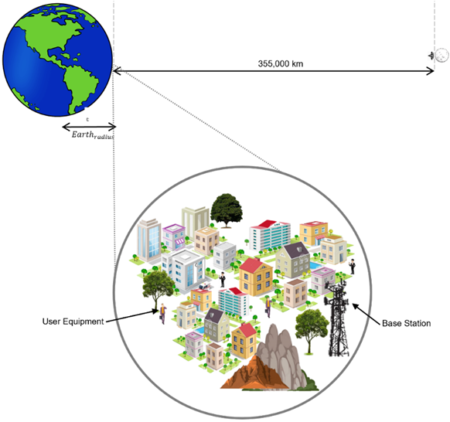
Table A.5.2.1.4
SRS – IMT co-channel results
SRS Station | SRS center frequency | IMT Station | Analysis | I/N result | Margin to the IMT protection criteria
Lunar Surface Transmitter | 3550 MHz | Base Station | Single Entry | -26.9 dB | 20.9 dB
Lunar Surface Transmitter | 3550 MHz | Base Station | Aggregate | -17.9 dB | 11.9 dB
Lunar Surface Transmitter | 3550 MHz | User Equipment | Single Entry | -61.3 dB | 55.3 dB
Lunar Surface Transmitter | 3550 MHz | User Equipment | Aggregate | -52.3 dB | 46.3 dB

A.5.2.1.6 Summary and analysis of the results of Study A
The interference-to-noise ratio metric shows that in the single entry static worst-case analysis, there is a margin of at least 20.9 dB to satisfy the IMT base station protection criteria and 55.3 dB margin for the IMT user equipment. For the aggregate interference analysis, the interference margin is 11.9 dB for the IMT base station and 46.3 dB for the IMT user equipment.

A5.3 Sharing and compatibility of the radiolocation service and SRS for lunar operations in the frequency band 3 500-3 600 MHz
This section shows the static worst case interference analysis between RLS and lunar surface SRS in the frequency band 3500-3800 MHz.
The technical and operational characteristics for SRS systems are based on those available in the preliminary draft of the new report ITU-R SA.[LUNAR.SRS STATIONS CHAR], as summaried below.
Table 2. Technical Characteristics of the Lunar SRS Systems
Station | Lunar Surface-to-Surface Transmitter
Frequency range | 3500 – 3800 MHz
Polarization | Linear ±45º / CP
Peak Gain (dBi) | 26.2
EIRP Density (dBW/MHz) | 22.3
Max. EIRP (dBW) | 42.3
Channel BW (MHz) | 100 MHz

The characteristics and protection criteria for radars operating in the radiolocation service (RLS) are based on Recommendation ITU-R M.1465-4 and summarized below.
Table 3. Characteristics of the radar systems
Parameter | Land-based | Shipborne | Airborne
Tuning range | 3.1-3.7 GHz | 2.9-3.7 GHz | 3.1-3.7 GHz
Antenna gain | 40 dBi | 42 dBi | 40 dBi
Receiver noise figure | 4 dB | 5 dB | 3 dB
Receiver IF bandwidth | 0.67 MHz | 10 MHz | 1 MHz
Protection criteria (I/N) | -6 dB

This analysis uses the propagation model based on Recommendation ITU-R P.525 for this scenario, as advised by Working Party 3J in Document 7B/58.

For the worst-case analysis, the following assumptions were considered:
- Main beam antenna coupling between the potentially interfering lunar SRS transmitters and the radar victim receiver
- Free space propagation loss assuming the minimum distance between the stations on the Earth and the Moon (355,000 km for ground and shipborne radars and 354,991 km for airborne), while atmospheric, depolarization and clutter losses are not considered
- In the present study, it is assumed that both systems operate at the same central frequency. A bandwidth correction factor (CF) is applied when the bandwidth of the potential interferer exceeds the bandwidth of the victim receiver under analysis. If the bandwidth of the interferer is equal to or smaller than that of the victim receiver, the bandwidth correction factor is 0
CF = 10 * log10bandwidthvictimbandwidthinterferer
- The interference-to-noise ratio (I/N) is calculated considering Lunar SRS transmitter pointing towards the radar victim receiver using the following equation:
INTotal= 1n (EIRPnθ,φ+CF-FSPL+Grxθ,φ)-Nrx)
where n is the number of lunar surface transmitters; EIRPnθ,φ is the equivalent isotropic radiated power of each lunar transmitter; FSPL is the free space path loss calculated using Rec. ITU-R P.525; (Grx)θ,φ is the radar victim receiver maximum antenna gain; and Nrx is the thermal noise power in the radar victim receiver bandwidth
- The receiver thermal noise power is calculated from the receiver noise figure (NF) using the formula provided in Recommendation ITU-R P.372-17
- The single I/N result is compared to the radar protection criteria (I/N ≤ 6 dB) to verify whether the radiolocation service protection is met

Figure 1. SRS–RLS Scenarios: (a) Land-based and shipborne; (b) Airborne.
(a)
(b)

SRS–RLS Scenario
Table. SRS – RLS co-channel results
SRS Station | SRS center frequency | Radar | Analysis | I/N result | Margin to the RLS protection criteria
Lunar Surface Transmitter | 3550 MHz | Land-based | Single Entry | -12.1 dB | 6.1 dB
Lunar Surface Transmitter | 3550 MHz | Shipborne | Single Entry | -11.1 dB | 5.1 dB
Lunar Surface Transmitter | 3550 MHz | Airborne | Single Entry | -11.1 dB | - dB

A5.[X] Summary and analysis of the results of studies
[Note: The summary should offer an objective overview, encompassing the results of sharing and compatibility studies, alongside any pertinent information applicable for future comparisons among studies. Additionally, it should address any mitigation techniques or proposals employed to safeguard services operating within the same band or adjacent bands, where applicable, to SRS lunar systems.]
ANNEX 6
Sharing and compatibility studies of SRS for lunar operations
in the frequency band 5 150-5 570 MHz

A6.1 Sharing and compatibility of radiolocation service (RLS) and SRS operating in the frequency band 5 150-5 570 MHz
[Note: Insert relevant sharing and compatibility studies for each of the identified service.]

A6.1.1 Study A [USA]

A.6.1.1.1 Technical and operational characteristics of SRS operating in the 5 150-5 570 MHz frequency range
The technical and operational characteristics for SRS systems are based on those available in the preliminary draft of the new report ITU-R SA.[LUNAR.SRS STATIONS CHAR], including Table 3.2-4, as summarized in Table A.6.1.1.1.
Table A.6.1.1.1
Technical Characteristics of the SRS Systems
Station | Lunar Surface-to-Surface Transmitter
Frequency range | 5 150-5 725 MHz
Polarization | Vertical
Peak Gain (dBi) | 6
EIRP Density (dBW/MHz) | -10
Max. EIRP (dBW) | 6
Channel BW (MHz) | 40 MHz

A.6.1.1.2 Technical and operational characteristics of radiolocation service (RLS) operating in the 5 250-5 570 MHz frequency range
The characteristics and protection criteria for radars operating in the radiolocation service are based on the Recommendation ITU-R M.1638, Table 3, as summarized in Table A.6.1.1.2.
Table A.6.1.1.2
Characteristics of the radar systems
Parameter | Ground | Airborne | Shipborne
Radar | L | S | Q
Frequency range | 5 350-5 850 MHz | 5 250-5 725 MHz | 5 450-5 825 MHz
Polarization | Vertical/left-  hand circular | Circular | Horizontal
Platform height/altitude | 20 m | 9000 m | 40 m
Antenna gain | 54 dBi | 40 dBi | 30 dBi
Antenna horizontal scan type | N/A (Tracking) | Continuous | 30-270 Sector
Receiver noise figure | 5 dB | 3.5 dB | 10 dB
Receiver IF bandwidth | 0.25 MHz | 1 MHz | 1 MHz
Protection criteria (I/N) | ‒6 dB

A.6.1.1.3 Propagation model
This sharing study includes the lunar SRS system on the surface of the Moon, and radiolocation service operating on Earth's surface. Therefore, Working Party 3J in Document 7B/58 recommends using the propagation model based on Recommendation ITU-R P.525 for this scenario.

A.6.1.1.4 Methodology
The methodology employed in this study is based on a static analysis of both single and aggregated worst-case interference. It evaluates whether, even under conditions of perfect antenna coupling between the systems, at the minimum distance between the stations on Earth and the Moon, and in the absence of antenna pointing errors and losses such as depolarization and clutter, the interference levels comply with the established ITU-R service protection criteria.

A.6.1.1.5 Study results
The study was conducted in accordance with the scenarios outlined in Figure A.6.1.1.1. For the worst-case analysis, the following assumptions were considered:
– Main beam antenna coupling between the potentially interfering lunar SRS transmitters and the radar victim receiver.
– Free space propagation loss assuming the minimum distance between the stations on the Earth and the Moon (355,000 km for ground and shipborne radars and 354,991 km for airborne), while atmospheric, depolarization and clutter losses are not considered.
– In the present study, it is assumed that both systems operate at the same central frequency. A bandwidth correction factor (CF) is applied when the bandwidth of the potential interferer exceeds the bandwidth of the victim receiver under analysis. If the bandwidth of the interferer is equal to or smaller than that of the victim receiver, the bandwidth correction factor is 0:
$$CF = 10 * \log_{10}\left(\frac{{bandwidth}_{victim}}{{bandwidth}_{interferer}}\right)$$
– The aggregate interference-to-noise ratio (I/N) is calculated considering Lunar SRS transmitters pointing towards the radar victim receiver using the following equation:
$${\left(\frac{I}{N}\right)}_{Total}= \sum_{1}^{n}{{ ({EIRP}_{n}}_{θ,φ}+CF-FSPL+{G_{rx}}_{θ,φ})-N_{rx})}$$
where n is the number of lunar surface transmitters; ${ {EIRP}_{n}}_{θ,φ}$is the equivalent isotropic radiated power of each lunar transmitter; FSPL is the free space path loss calculated using Rec. ITU-R P.525; ${{(G}_{rx})}_{θ,φ}$is the radar victim receiver maximum antenna gain; and $N_{rx}$ is the thermal noise power in the radar victim receiver bandwidth.
– The receiver thermal noise power is calculated from the receiver noise figure (NF) using the formula provided in Recommendation ITU-R P.372-17.
– The single and aggregate I/N results are compared to the radar protection criteria (I/N ≤ -6 dB) to verify whether the radiolocation service protection is met.
Figure A.6.1.1.1
SRS–RLS Scenarios: (a) Ground and shipborne; (b) Airborne.
(a)
(b)
Table A.6.1.1.3
SRS – RLS co-channel results
SRS Station | SRS center frequency | Radar | Analysis | I/N result | Margin to the radar protection criteria
Lunar Surface Transmitter | 5 370 MHz | Ground | Single Entry | –35.0 dB | 29.0 dB
Lunar Surface Transmitter | 5 370 MHz | Airborne | Single Entry | –47.5 dB | 41.5 dB
Lunar Surface Transmitter | 5 470 MHz | Shipborne | Single Entry | –64.2 dB | 58.2 dB

A.6.1.1.6 Summary and analysis of the results of Study A
The results of this study suggest that sharing between lunar SRS and Earth-based radars operating in the radiolocation service in the 5 150-5 570 MHz band (co-channel) is feasible. The interference-to-noise ratio metric shows that in the single entry static worst-case analysis, there is a margin of at least 29 dB to satisfy the radiolocation service protection criteria. That implies the aggregate interference from 794 lunar surface transmitters would still meet the RLS protection criteria in this band.

A6.1.2 Study B

A6.1.3 Study C

A6.2 Sharing studies between aeronautical radionavigation service (ARNS) and SRS operating in the frequency band 5 150-5 570 MHz

A6.2.1 Study A [USA]

A.6.2.1.1 Technical and operational characteristics of SRS operating in the 5 150-5 570 MHz frequency range
The technical and operational characteristics for SRS systems are based on those available in the preliminary draft of the new report ITU-R SA.[LUNAR.SRS STATIONS CHAR], including Table 3.2-4, as summarized in Table A.6.2.1.1.
Table A.6.2.1.1
Technical Characteristics of the SRS Systems
Station | Lunar Surface-to-Surface Transmitter
Frequency range | 5 150-5 725 MHz
Polarization | Linear ±45º
Peak Gain (dBi) | 6
EIRP Density (dBW/MHz) | −10
Max. EIRP (dBW) | 6
Channel BW (MHz) | 40 MHz

A.6.2.1.2 Technical and operational characteristics of aeronautical radionavigation service (ARNS) operating in the 5 250-5 570 MHz frequency range
The characteristics and protection criteria for radars operating in the aeronautical radionavigation service (ARNS) are based on the Recommendation ITU-R M.1638, Table 2, as summarized in Table A.6.2.1.2.
Table A.6.2.1.2
Characteristics of the radar system
Parameter | Airborne
Radar | D
Frequency range | 5 440 MHz
Polarization | Horizontal
Platform height/altitude | 9000 m (Aircraft altitude)
Antenna gain | 34 dBi
Antenna horizontal scan type | Continuous
Receiver noise figure | 5 dB
Receiver IF bandwidth | 1 MHz
Protection criteria (I/N) | −6 dB

A.6.2.1.3 Propagation model
This sharing study includes the lunar SRS system on the surface of the Moon, and radiolocation service operating on Earth's surface. Therefore, Working Party 3J in Document 7B/58 recommends using the propagation model based on Recommendation ITU-R P.525 for this scenario.

A.6.2.1.4 Methodology
The methodology employed in this study is based on a static analysis of both single and aggregated worst-case interference. It evaluates whether, even under conditions of perfect antenna coupling between the systems, at the minimum distance between the stations on Earth and the Moon, and in the absence of antenna pointing errors and losses such as depolarization and clutter, the interference levels comply with the established ITU-R service protection criteria.

A.6.2.1.5 Study results
The study was conducted in accordance with the scenario outlined in Figure A.6.2.1.1. For the worst-case analysis, the following assumptions were considered:
– Main beam antenna coupling between the potentially interfering lunar SRS transmitters and the radar victim receiver.
– Free space propagation loss assuming the minimum distance between the stations on the Earth and the Moon (354,991 km), considering the aircraft altitude, while atmospheric, depolarization and clutter losses are not considered.
– In the present study, it is assumed that both systems operate at the same central frequency. A bandwidth correction factor (CF) is applied when the bandwidth of the potential interferer exceeds the bandwidth of the victim receiver under analysis. If the bandwidth of the interferer is equal to or smaller than that of the victim receiver, the bandwidth correction factor is 0:
$$CF = 10 * \log_{10}\left(\frac{{bandwidth}_{victim}}{{bandwidth}_{interferer}}\right)$$
– The aggregate interference-to-noise ratio (I/N) is calculated considering Lunar SRS transmitters pointing towards the radar victim receiver using the following equation:
$${\left(\frac{I}{N}\right)}_{Total}= \sum_{1}^{n}{{ ({EIRP}_{n}}_{θ,φ}+CF-FSPL+{G_{rx}}_{θ,φ})-N_{rx})}$$
where n is the number of lunar surface transmitters; ${ {EIRP}_{n}}_{θ,φ}$is the equivalent isotropic radiated power of each lunar transmitter; FSPL is the free space path loss calculated using Rec. ITU-R P.525; ${{(G}_{rx})}_{θ,φ}$is the radar victim receiver maximum antenna gain; and $N_{rx}$ is the thermal noise power in the radar victim receiver bandwidth.
– The receiver thermal noise power is calculated from the receiver noise figure (NF) using the formula provided in Recommendation ITU-R P.372-17.
– The single and aggregate I/N results are compared to the radar protection criteria (I/N ≤ −6 dB) to verify whether the radiolocation service protection is met.
Figure A.6.2.1.1
SRS–ARNS Scenario
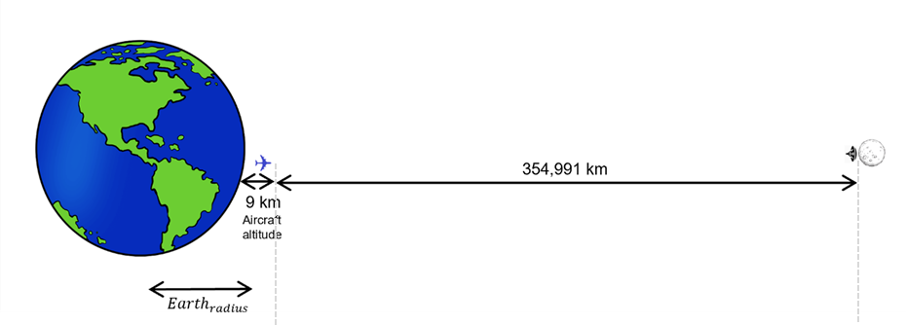
Table A.6.2.1.3
SRS – ARNS co-channel results
SRS Station | SRS center frequency | Radar | Analysis | I/N result | Margin to the radar protection criteria
Lunar Surface Transmitter | 5440 MHz | Airborne | Single Entry | −55.1 dB | 49.1 dB

A.6.2.1.6 Summary and analysis of the results of Study A
The results of this study suggest that sharing between lunar SRS and radars operating in the aeronautical radionavigation service in the 5 150-5 570 MHz band (co-channel) is feasible. The interference-to-noise ratio metric in the single entry static worst-case analysis shows a margin of at least 49.1 dB to satisfy the aeronautical radionavigation service protection criteria. This implies that the worst case aggregate interference from 81283 lunar transmitters would still meet the ARNS protection criteria.

A6.3 Sharing studies between aeronautical mobile service (AMS) and SRS operating in the frequency band 5 150-5 570 MHz

A6.3.1 Study A [USA]

A.6.3.1.1 Technical and operational characteristics of SRS operating in the 5 150-5 570 MHz frequency range
The technical and operational characteristics for SRS systems are based on those available in the preliminary draft of the new report ITU-R SA.[LUNAR.SRS STATIONS CHAR], including Table 3.2-4, as summarized in Table A.6.3.1.1.
Table A.6.3.1.1
Technical Characteristics of the SRS Systems
Station | Lunar Surface-to-Surface Transmitter
Frequency range | 5 150-5 725 MHz
Polarization | Linear ±45º
Peak Gain (dBi) | 6
EIRP Density (dBW/MHz) | −10
Max. EIRP (dBW) | 6
Channel BW (MHz) | 40 MHz

A.6.3.1.2 Technical and operational characteristics of aeronautical mobile service (AMS) operating in the 5 150-5 250 MHz frequency range
The characteristics and protection criteria for AMS are based on the Recommendation ITU-R M.2122, Table 1, as summarized in Table A.6.3.1.2.
Table A.6.3.1.2
Characteristics of the AMS ground system
Parameter | Aeronautical mobile telemetry system
Frequency range | 5 150 – 5 160 MHz
Channel bandwidth | 8 MHz
Receiver antenna gain | 40 dBi
Platform height | 40 m
Receiver noise figure | 9 dB
Protection criteria (I/N) | −6 dB

A.6.3.1.3 Propagation model
This sharing study includes the lunar SRS system on the surface of the Moon, and radiolocation service operating on Earth's surface. Therefore, Working Party 3J in Document 7B/58 recommends using the propagation model based on Recommendation ITU-R P.525 for this scenario.

A.6.3.1.4 Methodology
The methodology employed in this study is based on a static analysis of both single and aggregated worst-case interference. It evaluates whether, even under conditions of perfect antenna coupling between the systems, at the minimum distance between the stations on Earth and the Moon, and in the absence of antenna pointing errors and losses such as depolarization and clutter, the interference levels comply with the established ITU-R service protection criteria.

A.6.3.1.5 Study results
The study was conducted in accordance with the scenario outlined in Figure A.6.3.1.1. For the worst-case analysis, the following assumptions were considered:
– Main beam antenna coupling between the potentially interfering lunar SRS transmitters and the AMS victim receiver.
– Free space propagation loss assuming the minimum distance between the stations on the Earth and the Moon (355,000 km), while atmospheric, depolarization and clutter losses are not considered.
– In the present study, it is assumed that both systems operate at the same central frequency. A bandwidth correction factor (CF) is applied when the bandwidth of the potential interferer exceeds the bandwidth of the victim receiver under analysis. If the bandwidth of the interferer is equal to or smaller than that of the victim receiver, the bandwidth correction factor is 0:
$$CF = 10 * \log_{10}\left(\frac{{bandwidth}_{victim}}{{bandwidth}_{interferer}}\right)$$
– The aggregate interference-to-noise ratio (I/N) is calculated considering Lunar SRS transmitters pointing towards the radar victim receiver using the following equation:
$${\left(\frac{I}{N}\right)}_{Total}= \sum_{1}^{n}{{ ({EIRP}_{n}}_{θ,φ}+CF-FSPL+{G_{rx}}_{θ,φ})-N_{rx})}$$
where n is the number of lunar surface transmitters; ${ {EIRP}_{n}}_{θ,φ}$is the equivalent isotropic radiated power of each lunar transmitter; FSPL is the free space path loss calculated using Rec. ITU-R P.525; ${{(G}_{rx})}_{θ,φ}$is the AMS victim receiver maximum antenna gain; and $N_{rx}$ is the thermal noise power in the AMS victim receiver bandwidth.
– The receiver thermal noise power is calculated from the receiver noise figure (NF) using the formula provided in Recommendation ITU-R P.372-17.
– The single and aggregate I/N results are compared to the radar protection criteria (I/N ≤ −6 dB) to verify whether the AMS protection is met.
Figure A.6.3.1.1
SRS–AMS Scenario
Table A.6.3.1.3
SRS – AMS co-channel results
SRS Station | AMS center frequency | AMS | Analysis | I/N result | Margin to the AMS protection criteria
Lunar Surface Transmitter | 5155 MHz | Ground | Single Entry | −52.6 dB | 46.6 dB

A.6.3.1.6 Summary and analysis of the results of Study A
The results of this study suggest that sharing between SRS and aeronautical mobile service (AMS) operating service in the 5 150-5 570 MHz band (co-channel) is feasible. The interference-to-noise ratio metric shows that in the single entry static worst-case analysis, there is a margin of at least 46.6 dB to satisfy the AMS protection criteria. This implies that even the worst case aggregate interference from 45708 lunar surface transmitters would not exceed the AMS protection criterion in this band.

A6.[X] Summary and analysis of the results of studies
[Note: The summary should offer an objective overview, encompassing the results of sharing and compatibility studies, alongside any pertinent information applicable for future comparisons among studies. Additionally, it should address any mitigation techniques or proposals employed to safeguard services operating within the same band or adjacent bands, where applicable, to SRS lunar systems.]

ANNEX 7
Sharing and compatibility studies of SRS for lunar operations
in the frequency band 5 570-5 725 MHz

A7.1 Sharing and compatibility of radiolocation service (RLS) and SRS operating in the frequency band 5 570-5 725 MHz
[Note: Insert relevant sharing and compatibility studies for each of the identified service.]

A7.1.1 Study A [USA]

A.7.1.1.1 Technical and operational characteristics of SRS operating in the 5 570-5 725 MHz frequency range
The technical and operational characteristics for SRS systems are based on those available in the preliminary draft of the new report ITU-R SA.[LUNAR.SRS STATIONS CHAR], including Table 3.2-4, as summarized in Table A.7.1.1.1.
Table A.7.1.1.1
Technical Characteristics of the SRS Systems
Station | Lunar Surface-to-Surface Transmitter
Frequency range | 5 150-5 725 MHz
Polarization | Linear ±45º
Peak Gain (dBi) | 6
EIRP Density (dBW/MHz) | -10
Max. EIRP (dBW) | 6
Channel BW (MHz) | 40 MHz

A.7.1.1.2 Technical and operational characteristics of radiolocation service (RLS) operating in the 5 570-5 725 MHz frequency range
The characteristics and protection criteria for radars operating in the radiolocation service are based on the Recommendation ITU-R M.1638, Table 3, as summarized in Table A.7.1.1.2.
Table A.7.1.1.2
Characteristics of the radar systems
Parameter | Ground | Airborne | Shipborne
Radar | L | S | Q
Frequency range | 5 350-5 850 MHz | 5 250-5 725 MHz | 5 450-5 825 MHz
Polarization | Vertical/left-  hand circular | Circular | Horizontal
Platform height/altitude | 20 m | 9000 m | 40 m
Antenna gain | 54 dBi | 40 dBi | 30 dBi
Antenna horizontal scan type | N/A (Tracking) | Continuous | 30-270 Sector
Receiver noise figure | 5 dB | 3.5 dB | 10 dB
Receiver IF bandwidth | 0.25 MHz | 1 MHz | 1 MHz
Protection criteria (I/N) | ‒6 dB

A.7.1.1.3 Propagation model
This sharing study includes the lunar SRS system on the surface of the Moon, and radiolocation service operating on Earth's surface. Therefore, Working Party 3J in Document 7B/58 recommends using the propagation model based on Recommendation ITU-R P.525 for this scenario.

A.7.1.1.4 Methodology
The methodology employed in this study is based on a static analysis of both single and aggregated worst-case interference. It evaluates whether, even under conditions of perfect antenna coupling between the systems, at the minimum distance between the stations on Earth and the Moon, and in the absence of antenna pointing errors and losses such as depolarization and clutter, the interference levels comply with the established ITU-R service protection criteria.

A.7.1.1.5 Study results
The study was conducted in accordance with the scenarios outlined in Figures A.7.1.1.1 and A.7.1.1.2. For the worst-case analysis, the following assumptions were considered:
– Main beam antenna coupling between the potentially interfering lunar SRS transmitters and the radar victim receiver.
– Free space propagation loss assuming the minimum distance between the stations on the Earth and the Moon (355,000 km for ground and shipborne scenarios and 354,991 km for airborne), while atmospheric, depolarization and clutter losses are not considered.
– In the present study, it is assumed that both systems operate at the same central frequency. A bandwidth correction factor (CF) is applied when the bandwidth of the potential interferer exceeds the bandwidth of the victim receiver under analysis. If the bandwidth of the interferer is equal to or smaller than that of the victim receiver, the bandwidth correction factor is 0:
$$CF = 10 * \log_{10}\left(\frac{{bandwidth}_{victim}}{{bandwidth}_{interferer}}\right)$$
– The aggregate interference-to-noise ratio (I/N) is calculated considering Lunar SRS transmitters pointing towards the radar victim receiver using the following equation:
$${\left(\frac{I}{N}\right)}_{Total}= \sum_{1}^{n}{{ ({EIRP}_{n}}_{θ,φ}+CF-FSPL+{G_{rx}}_{θ,φ})-N_{rx})}$$
where n is the number of lunar surface transmitters; ${ {EIRP}_{n}}_{θ,φ}$is the equivalent isotropic radiated power of each lunar transmitter; FSPL is the free space path loss calculated using Rec. ITU-R P.525; ${{(G}_{rx})}_{θ,φ}$is the radar victim receiver maximum antenna gain; and $N_{rx}$ is the thermal noise power in the radar victim receiver bandwidth.
– The receiver thermal noise power is calculated from the receiver noise figure (NF) using the formula provided in Recommendation ITU-R P.372-17.
– The single and aggregate I/N results are compared to the radar protection criteria (I/N ≤ −6 dB) to verify whether the radiolocation service protection is met.
Figure A.7.1.1.1
SRS–RLS Scenarios: (a) Ground and shipborne; (b) Airborne
(a)
(b)
Table A.7.1.1.3
SRS – RLS co-channel results
SRS Station | SRS center frequency | Radar | Analysis | I/N result | Margin to the radar protection criteria
Lunar Surface Transmitter | 5590 MHz | Ground | Single Entry | −35.3 dB | 29.3 dB
Lunar Surface Transmitter | 5590 MHz | Airborne | Single Entry | −47.8 dB | 41.8 dB
Lunar Surface Transmitter | 5590 MHz | Shipborne | Single Entry | −64.3 dB | 58.3 dB

A.7.1.1.6 Summary and analysis of the results of Study A
The results of this study suggest that sharing between SRS and radars operating in the radiolocation service in the 5 570-5 725 MHz band (co-channel) is feasible. The interference-to-noise ratio metric shows that in the single entry static worst-case analysis, there is a margin of at least 29.3 dB to satisfy the radiolocation service protection criteria. This implies that the worst case aggregate interference from 851 lunar surface transmitters would still meet the RLS protection criteria in this band.

A7.1.2 Study B

A7.1.3 Study C

A7.2 Sharing and compatibility of [existing service YY] and SRS operating in the frequency band 5 570-5 725 MHz

A7.3 …

A7.[X] Summary and analysis of the results of studies
[Note: The summary should offer an objective overview, encompassing the results of sharing and compatibility studies, alongside any pertinent information applicable for future comparisons among studies. Additionally, it should address any mitigation techniques or proposals employed to safeguard services operating within the same band or adjacent bands, where applicable, to SRS lunar systems.]

ANNEX 8
Sharing and compatibility studies of SRS for lunar operations
in the frequency band 5 775-5 925 MHz

A8.1 Sharing and compatibility of radiolocation service (RLS) and SRS operating in the frequency band 5 775-5 925 MHz
[Note: Insert relevant sharing and compatibility studies for each of the identified service.]

A8.1.1 Study A [USA]

A.8.1.1.1 Technical and operational characteristics of SRS operating in the 5 775-5 925 MHz frequency range
The technical and operational characteristics for SRS systems are based on those available in the preliminary draft of the new report ITU-R SA.[LUNAR.SRS STATIONS CHAR], including Table 3.2-4, as summarized in Table A.8.1.1.1.
Table A.8.1.1.1
Technical Characteristics of the SRS Systems
Station | Lunar Surface-to-Surface Transmitter
Frequency range | 5 775-5 855 MHz | 5 855-5 925 MHz
Polarization | Vertical | Linear ±45º
Peak Gain (dBi) | 6 | 3
EIRP Density (dBW/MHz) | −10 | −16
Max. EIRP (dBW) | 6 | 0
Channel BW (MHz) | 40 MHz

A.8.1.1.2 Technical and operational characteristics of radiolocation service (RLS) operating in the 5 775-5 925 MHz frequency range
The characteristics and protection criteria for radars operating in the radiolocation service are based on the Recommendation ITU-R M.1638, Table 3, as summarized in Table A.8.1.1.2.
Table A.8.1.1.2
Characteristics of the radar systems
Parameter | Ground | Ground | Shipborne
Radar | L | N | Q
Frequency range | 5 350-5 850 MHz | 5 400-5900 MHz | 5 450-5 825 MHz
Polarization | Vertical/left-  hand circular | Vertical/left-  hand circular | Horizontal
Platform height/altitude | 20 m | 20 | 40 m
Antenna gain | 54 dBi | 45.9 dBi | 30 dBi
Antenna horizontal scan type | N/A (Tracking) | N/A (Tracking) | 30-270 Sector
Receiver noise figure | 5 dB | 11 dB | 10 dB
Receiver IF bandwidth | 0.25 MHz | 2 MHz | 1 MHz
Protection criteria (I/N) | ‒6 dB

A.8.1.1.3 Propagation model
This sharing study includes the lunar SRS system on the surface of the Moon, and radiolocation service operating on Earth's surface. Therefore, Working Party 3J in Document 7B/58 recommends using the propagation model based on Recommendation ITU-R P.525 for this scenario.

A.8.1.1.4 Methodology
The methodology employed in this study is based on a static analysis of both single and aggregated worst-case interference. It evaluates whether, even under conditions of perfect antenna coupling between the systems, at the minimum distance between the stations on Earth and the Moon, and in the absence of antenna pointing errors and losses such as depolarization and clutter, the interference levels comply with the established ITU-R service protection criteria.

A.8.1.1.5 Study results
The study was conducted in accordance with the scenario outlined in Figure A.8.1.1.1. For the worst-case analysis, the following assumptions were considered:
– Main beam antenna coupling between the potentially interfering lunar SRS transmitters and the radar victim receiver.
– Free space propagation loss assuming the minimum distance between the stations on the Earth and the Moon (355,000 km), while atmospheric, depolarization and clutter losses are not considered.
– In the present study, it is assumed that both systems operate at the same central frequency. A bandwidth correction factor (CF) is applied when the bandwidth of the potential interferer exceeds the bandwidth of the victim receiver under analysis. If the bandwidth of the interferer is equal to or smaller than that of the victim receiver, the bandwidth correction factor is 0:
$$CF = 10 * \log_{10}\left(\frac{{bandwidth}_{victim}}{{bandwidth}_{interferer}}\right)$$
– The aggregate interference-to-noise ratio (I/N) is calculated considering Lunar SRS transmitters pointing towards the radar victim receiver using the following equation:
$${\left(\frac{I}{N}\right)}_{Total}= \sum_{1}^{n}{{ ({EIRP}_{n}}_{θ,φ}+CF-FSPL+{G_{rx}}_{θ,φ})-N_{rx})}$$
where n is the number of lunar surface transmitters; ${ {EIRP}_{n}}_{θ,φ}$is the equivalent isotropic radiated power of each lunar transmitter; FSPL is the free space path loss calculated using Recommendation ITU-R P.525; ${{(G}_{rx})}_{θ,φ}$is the radar victim receiver maximum antenna gain; and $N_{rx}$ is the thermal noise power in the radar victim receiver bandwidth.
– The receiver thermal noise power is calculated from the receiver noise figure (NF) using the formula provided in Recommendation ITU-R P.372-17.
– The single and aggregate I/N results are compared to the radar protection criteria (I/N ≤ −6 dB) to verify whether the radiolocation service protection is met.
Figure A.8.1.1.1
SRS-RLS Scenario
Table A.8.1.1.3
SRS – RLS co-channel results
SRS Station | SRS center frequency | Radar | Analysis | I/N result | Margin to the radar protection criteria
Lunar Surface Transmitter | 5795 MHz | Ground (L) | Single Entry | -35.7 dB | 29.7 dB
Lunar Surface Transmitter | 5875 MHz | Ground (N) | Single Entry | -42.9 dB | 36.9 dB
Lunar Surface Transmitter | 5795 MHz | Shipborne (Q) | Single Entry | -64.7 dB | 58.7 dB

A.8.1.1.6 Summary and analysis of the results of Study A

A8.1.2 Study B

A8.1.3 Study C

A8.2 Sharing studies between fixed service and SRS for lunar operations in the frequency band 5 775 - 5 925 MHz

A8.2.1 Study A [USA]

A.8.2.1.1 Technical and operational characteristics of SRS operating in the 5 775-5 925 MHz frequency range
The technical and operational characteristics for SRS systems are based on those available in the preliminary draft of the new Report ITU-R SA.[LUNAR.SRS STATIONS CHAR], including Table 3.2-4, as summarized in Table A.8.2.1.1.
Table A.8.2.1.1
Technical Characteristics of the SRS Systems
Station | Lunar Surface-to-Surface Transmitter
Frequency range | 5 855-5 925 MHz
Polarization | Linear ±45º
Peak Gain (dBi) | 6
EIRP Density (dBW/MHz) | −3
Max. EIRP (dBW) | 13
Channel BW (MHz) | 40 MHz

A.8.2.1.2 Technical and operational characteristics of fixed service operating in the in the 5 775-5 925 MHz frequency range
The Document 7B/56 provides relevant technical information to support studies between SRS and Fixed Services (FS) under agenda item 1.15. The characteristics for fixed service (FS) for point-to-point (PP) systems are based on the information contained in the Report ITU-R F.2108, Table 9, as summarized in Table A.8.2.1.2.
Table A.8.2.1.2
Characteristics of the FS (PP) systems
Parameter | Value
Frequency range | 5 850-7 025 MHz
Modulation | 64-QAM
Receiver noise bandwidth | 10 MHz
Antenna height | 30 m
Antenna pattern | Recommendation ITU-R F.699
Antenna gain | 43 dBi
Feeder loss | 3 dB
Receiver thermal noise ($N_{rx}$) | −130 dBW
Protection criteria (I/N) | −10 dB

A.8.2.1.3 Propagation model
This sharing study includes the lunar SRS system on the surface of the Moon, and fixed services operating on Earth's surface. Therefore, Working Party 3J in Document 7B/58 recommends using the propagation model based on Recommendation ITU-R P.525 for this scenario.

A.8.2.1.4 Methodology
The methodology employed in this study is based on a static analysis of both single and aggregated worst-case interference. It evaluates whether, even under conditions of perfect antenna coupling between the systems, at the minimum distance between the stations on Earth and the Moon, and in the absence of antenna pointing errors and losses such as depolarization and clutter, the interference levels comply with the established ITU-R service protection criteria.

A.8.2.1.5 Study results
The study was conducted in accordance with the scenario outlined in Figure A.8.2.1.1. For the worst-case analysis, the following assumptions were considered:
– Main beam antenna coupling between the potentially interfering lunar SRS transmitters and the FS victim receiver.
– Free space propagation loss assuming the minimum distance between the stations on the Earth and the Moon (355,000 km), while atmospheric, depolarization and clutter losses are not considered.
– In the present study, it is assumed that both systems operate at the same central frequency. A bandwidth correction factor (CF) is applied when the bandwidth of the potential interferer exceeds the bandwidth of the victim receiver under analysis. If the bandwidth of the interferer is equal to or smaller than that of the victim receiver, the bandwidth correction factor is 0:
$$CF = 10 * \log_{10}\left(\frac{{bandwidth}_{victim}}{{bandwidth}_{interferer}}\right)$$
– The aggregate interference-to-noise ratio (I/N) is calculated considering Lunar SRS transmitters pointing towards the FS victim receiver using the following equation:
$${\left(\frac{I}{N}\right)}_{Total}= \sum_{1}^{n}{{ ({EIRP}_{n}}_{θ,φ}+CF-FSPL-F_{loss}+{G_{rx}}_{θ,φ})-N_{rx})}$$
where n is the number of lunar surface transmitters; ${ {EIRP}_{n}}_{θ,φ}$is the equivalent isotropic radiated power of each lunar transmitter; FSPL is the free space path loss calculated using Rec. ITU-R P.525; $F_{loss}$ is the FS feeder loss; ${{(G}_{rx})}_{θ,φ}$is the FS victim receiver maximum antenna gain; and $N_{rx}$ is the thermal noise power in the FS victim receiver bandwidth.
– The single and aggregate I/N results are compared to the FS protection criteria (I/N ≤ −10 dB) to verify whether the FS protection is met.
Figure A.8.2.1.1
SRS–FS Scenario
Table A.8.2.1.3
SRS - FS co-channel results
SRS Station | SRS center frequency | Analysis | I/N result | Margin to the FS protection criteria
Lunar Surface Transmitter | 5875 MHz | Single Entry | −41.8 dB | 31.8 dB

A.8.2.1.6 Summary and analysis of the results of Study A
The results of this study suggest that sharing between SRS and terrestrial FS operating in the 5 775-5 925 MHz band (co-channel) is feasible. The interference-to-noise ratio metric shows that even in the static worst-case analysis, including single and aggregated potential interferers, there is a margin of at least 31.8 dB to satisfy the FS protection criteria. This implies that the worst case aggregate interference from even 1513 lunar surface transmitters would not exceed the FS protection criterion.

A8.3 …

A8.[X] Summary and analysis of the results of studies
[Note: The summary should offer an objective overview, encompassing the results of sharing and compatibility studies, alongside any pertinent information applicable for future comparisons among studies. Additionally, it should address any mitigation techniques or proposals employed to safeguard services operating within the same band or adjacent bands, where applicable, to SRS lunar systems.]
ANNEX 9
Sharing and compatibility studies of SRS for lunar operations
in the frequency band 7 190-7 235

A9.1 Sharing and compatibility of [existing service XX] and SRS (space-to-space) operating in the frequency band 7 190-7 235 MHz
[Note: Insert relevant sharing and compatibility studies for each of the identified service.]

A9.1.1 Study A

A9.1.2 Study B

A9.1.3 Study C

A9.2 Sharing and compatibility of [existing service YY] and SRS (space-to-space) operating in the frequency band 7 190-7 235 MHz

A9.3 …

A9.[X] Summary and analysis of the results of studies
[Note: The summary should offer an objective overview, encompassing the results of sharing and compatibility studies, alongside any pertinent information applicable for future comparisons among studies. Additionally, it should address any mitigation techniques or proposals employed to safeguard services operating within the same band or adjacent bands, where applicable, to SRS lunar systems.]

ANNEX 10
Sharing and compatibility studies of SRS for lunar operations
in the frequency band 8 450-8 500 MHz

A10.1 Sharing and compatibility of [existing service XX] and SRS (space-to-space) operating in the frequency band 8 450-8 500 MHz
[Note: Insert relevant sharing and compatibility studies for each of the identified service.]

A10.1.1 Study A

A10.1.2 Study B

A10.1.3 Study C

A10.2 Sharing and compatibility of [existing service YY] and SRS (space-to-space) operating in the frequency band 8 450-8 500 MHz

A10.3 …

A10.3[X] Summary and analysis of the results of studies
[Note: The summary should offer an objective overview, encompassing the results of sharing and compatibility studies, alongside any pertinent information applicable for future comparisons among studies. Additionally, it should address any mitigation techniques or proposals employed to safeguard services operating within the same band or adjacent bands, where applicable, to SRS lunar systems.]

ANNEX 11
Sharing and compatibility studies of SRS LDRS (Lunar Data Relay Satellite) system operations in the frequency bands 7 190-7 235 MHz
and 8 450-8 500 MHz

A11.1 Sharing and compatibility of terrestrial services and SRS LDRS systems operating in the frequency bands 7 190-7 235 MHz and 8 450-8 500 MHz
[Note: Insert relevant sharing and compatibility studies for each of the identified service.]

A11.1.1 Study A [Russian Federation]

A11.1.1.1 SRS (space-space) characteristics in the frequency bands 7 190-7 235 MHz and 8 450-8 500 MHz
Information on technical and operational parameters of and concept of operation for Lunar data relay satellite (LDRS) system are provided in section 3.4 of the Preliminary draft new Report ITU-R SA.[LUNAR.SRS STATIONS CHAR].
LDRS would be located in Lagrange points L1 and L2 of the Earth-Moon system, using Halo orbits with time period of 13-16 days. LDRS will provide tracking, telemetry and telecommand (TT&C) functions, as well as voice and data communication links for various Lunar space stations (LSS): Orbiters (6 000 km maximum orbit height), Landers and Rovers, as well as planned manned missions. Forward inter-orbit links (LDRS – LSS) will be operated in the frequency band 7 190-7 235 MHz. Return inter-orbit links (LSS – LDRS) will be operated in the frequency band 8 450-8 500 MHz.
LDRS will provide TT&C and low data rate/voice communications in multiple access links, involving CDMA and TDMA schemes, as well as medium data rate/voice communications in single access links.
Figure A11.1.1.1
LDRS system communication links
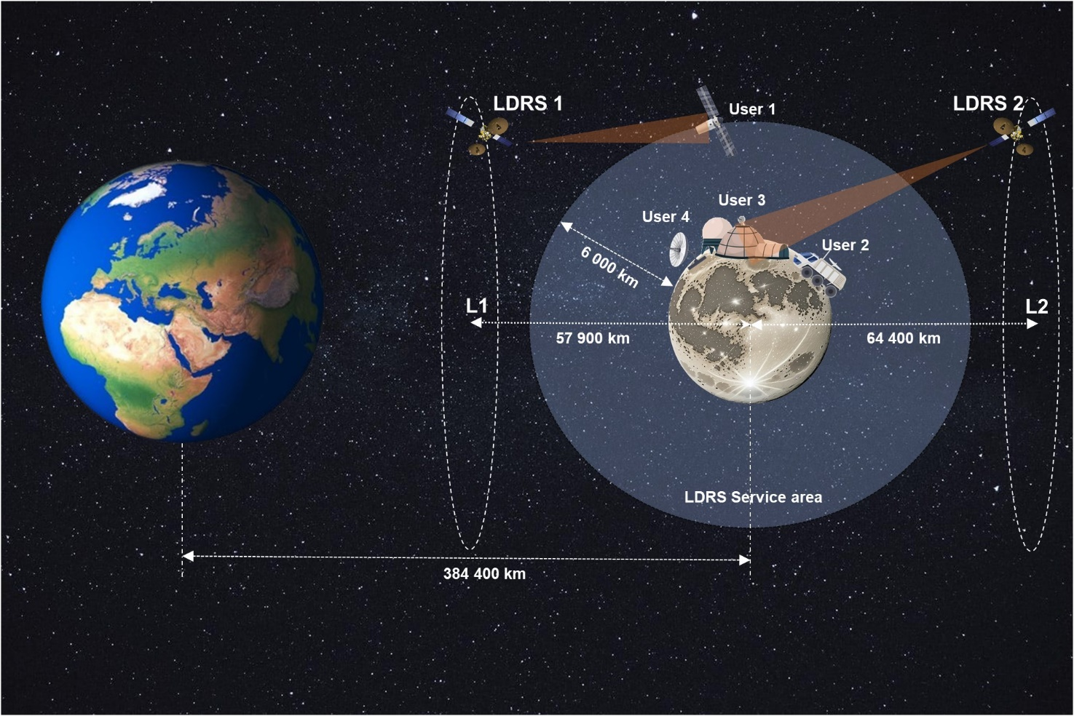
Technical and operational characteristics of LDRS links are provided in Table 1.
Table A11.1.1.1
LDRS Links | LDRS – LSS (Multiple access) | LDRS – LSS (Single access) | LSS – LDRS (Multiple access) | LSS – LDRS (Single access)
Frequency band(s) | 7 190-7 235 MHz | 7 190-7 235 MHz | 8 450-8 500 MHz | 8 450-8 500 MHz
Data rate per user | 8-64 kbps  (TT&C, voice and low data rate) | 4-12 Mbps | 8-64 kbps  (TT&C, voice and low data rate) | 4-24 Mbps
Number of users | Up to 8 | 1 | Up to 8 | 1
Total data rate | 64 kbps | 12 Mbps | 64 kbps | 24 Mbps
Necessary bandwidth, MHz | 6 | 10 | 6 | 10
Operating distance to LDRS, km | 51 000-80 400 | 51 000-80 400 | 51 000-80 400 | 51 000-80 400
Peak Transmitting antenna gain, dBi | 22.6 | 47.7 | 29.9 | 29.9-39.5
Antenna gain pattern | Rec. ITU-R S.672  (Ls –20 dB) | Rec. ITU-R S.672  (Ls –20 dB) | Rec. ITU-R S.672  (Ls –20 dB) | Rec. ITU-R S.672  (Ls –20 dB)
EIRP, dBW | 38.5 | 63.6 | 38.9 | 38.9-50.5
Multiple access scheme | CDMA, TDMA | – | CDMA | –
Receiving antenna gain | 28.6 | 28.6 | 23.9 | 49
Antenna gain pattern | Rec. ITU-R S.672  (Ls –20 dB) | Rec. ITU-R S.672  (Ls –20 dB) | Rec. ITU-R S.672  (Ls –20 dB) | Rec. ITU-R S.672  (Ls –20 dB)
System noise temperature | 350 K | 350 K | 800 K | 800 K

A11.1.1.2 Assessment of power flux-density at the Earth’s surface, produced by LDRS emissions
The power flux-density at the Earth’s surface, produced by LDRS emissions is given by:
${PFD}_{SRS}\left[dBw/m^{2}∙4 kHz\right]= {EIRP}_{SRS}(θ)-10$log($B_{N}) +36-10\log_{10}{4∙π∙{D(δ)}^{2}}-60$
${EIRP}_{SRS}(θ)$ Off-axis EIRP of the LDRS/LSS towards the Earth surface;
D($δ$) slant distance between LDRS/LSS and the Earth surface, as a function of angle of arrival above the horizontal plane, km
$B_{N}$ necessary bandwidth of emissions, MHz.
Several assumptions were made in the study:
– Transmitting antenna of the LDRS in L2 point, operating forward inter-orbit link (LDRS – LSS) points towards the Earth surface;
– Transmitting antenna of the LDRS in L1 point, operating forward inter-orbit link (LDRS – LSS) points towards the Earth surface with off-axis gain of 0 dBi;
– Transmitting antenna of the LSS, communicating with LDRS in L1 point in return inter-orbit link (LSS – LDRS) points towards the Earth surface, LSS is located at the minimal distance from the Earth surface;
– Transmitting antenna of the LSS, communicating with LDRS in L2 point in return inter-orbit link (LSS – LDRS) points towards the Earth surface with off-axis gain of 0 dBi, LSS is located at the minimal distance from the Earth surface.
Minimal distances between LDRS, LSS and the Earth surface, used in the study, are provided in Figure 2.
Figure A11.1.1.2
LDRS system communication links
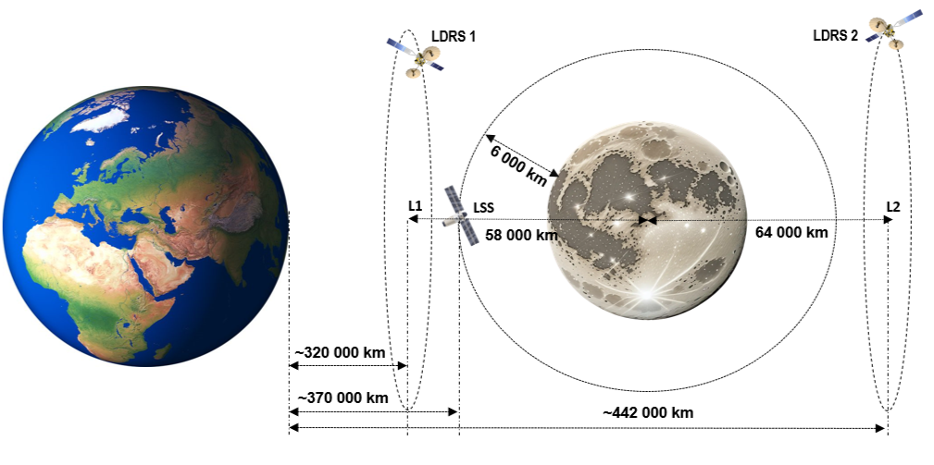

A11.1.1.3 Assessment results
Tables 2-9 provide results of pfd assessment.

Table A11.1.1.2
Forward inter-orbit link (LDRS – LSS), L1 POINT, MA
Angle of arrival,  degrees, δ | EIRP(θ) | D(δ) | Calculated PFD | Table 21-4  PFD limit | Spreading loss | Margin
deg | dBW | km | dBW/m²  in 4 kHz | dBW/m²  in 4 kHz | dB | dB
0 | 15.9 | 326 315.7 | –197.1 | –152.0 | 181.3 | 45.1
1 | 15.9 | 326 204.4 | –197.1 | –152.0 | 181.3 | 45.1
2 | 15.9 | 326 093.2 | –197.1 | –152.0 | 181.3 | 45.1
3 | 15.9 | 325 982.0 | –197.1 | –152.0 | 181.3 | 45.1
4 | 15.9 | 325 871.1 | –197.1 | –152.0 | 181.3 | 45.1
5 | 15.9 | 325 760.3 | –197.1 | –152.0 | 181.3 | 45.1
10 | 15.9 | 325 210.0 | –197.1 | –149.5 | 181.2 | 47.6
15 | 15.9 | 324 669.1 | –197.1 | –147.0 | 181.2 | 50.1
20 | 15.9 | 324 141.6 | –197.1 | –144.5 | 181.2 | 52.6
25 | 15.9 | 323 631.3 | –197.1 | –142.0 | 181.2 | 55.1
30 | 15.9 | 323 142.2 | –197.0 | –142.0 | 181.2 | 55.0
35 | 15.9 | 322 677.9 | –197.0 | –142.0 | 181.2 | 55.0
40 | 15.9 | 322 241.7 | –197.0 | –142.0 | 181.2 | 55.0
45 | 15.9 | 321 836.9 | –197.0 | –142.0 | 181.1 | 55.0
50 | 15.9 | 321 466.4 | –197.0 | –142.0 | 181.1 | 55.0
55 | 15.9 | 321 132.9 | –197.0 | –142.0 | 181.1 | 55.0
60 | 15.9 | 320 838.9 | –197.0 | –142.0 | 181.1 | 55.0
65 | 15.9 | 320 586.4 | –197.0 | –142.0 | 181.1 | 55.0
70 | 15.9 | 320 377.3 | –197.0 | –142.0 | 181.1 | 55.0
75 | 15.9 | 320 213.1 | –197.0 | –142.0 | 181.1 | 55.0
80 | 15.9 | 320 094.9 | –197.0 | –142.0 | 181.1 | 55.0
84 | 15.9 | 320 034.1 | –197.0 | –142.0 | 181.1 | 55.0
85 | 15.9 | 320 023.6 | –197.0 | –142.0 | 181.1 | 55.0
90 | 15.9 | 320 000.00 | –197.0 | –142.0 | 181.1 | 55.0
Table A11.1.1.3
Forward inter-orbit link (LDRS – LSS), L1 POINT, SA
Angle of arrival,  degrees, δ | EIRP(θ) | D(δ) | Calculated PFD | Table 21-4  PFD limit | Spreading loss | Margin
deg | dBW | km | dBW/m²  in 4 kHz | dBW/m²  in 4 kHz | dB | dB
0 | 15.9 | 326 315.7 | –199.3 | –152.0 | 181.3 | 47.3
1 | 15.9 | 326 204.4 | –199.3 | –152.0 | 181.3 | 47.3
2 | 15.9 | 326 093.2 | –199.3 | –152.0 | 181.3 | 47.3
3 | 15.9 | 325 982.0 | –199.3 | –152.0 | 181.3 | 47.3
4 | 15.9 | 325 871.1 | –199.3 | –152.0 | 181.3 | 47.3
5 | 15.9 | 325 760.3 | –199.3 | –152.0 | 181.3 | 47.3
10 | 15.9 | 325 210.0 | –199.3 | –149.5 | 181.2 | 49.8
15 | 15.9 | 324 669.1 | –199.3 | –147.0 | 181.2 | 52.3
20 | 15.9 | 324 141.6 | –199.3 | –144.5 | 181.2 | 54.8
25 | 15.9 | 323 631.3 | –199.3 | –142.0 | 181.2 | 57.3
30 | 15.9 | 323 142.2 | –199.3 | –142.0 | 181.2 | 57.3
35 | 15.9 | 322 677.9 | –199.2 | –142.0 | 181.2 | 57.2
40 | 15.9 | 322 241.7 | –199.2 | –142.0 | 181.2 | 57.2
45 | 15.9 | 321 836.9 | –199.2 | –142.0 | 181.1 | 57.2
50 | 15.9 | 321 466.4 | –199.2 | –142.0 | 181.1 | 57.2
55 | 15.9 | 321 132.9 | –199.2 | –142.0 | 181.1 | 57.2
60 | 15.9 | 320 838.9 | –199.2 | –142.0 | 181.1 | 57.2
65 | 15.9 | 320 586.4 | –199.2 | –142.0 | 181.1 | 57.2
70 | 15.9 | 320 377.3 | –199.2 | –142.0 | 181.1 | 57.2
75 | 15.9 | 320 213.1 | –199.2 | –142.0 | 181.1 | 57.2
80 | 15.9 | 320 094.9 | –199.2 | –142.0 | 181.1 | 57.2
84 | 15.9 | 320 034.1 | –199.2 | –142.0 | 181.1 | 57.2
85 | 15.9 | 320 023.6 | –199.2 | –142.0 | 181.1 | 57.2
90 | 15.9 | 320 000.00 | –199.2 | –142.0 | 181.1 | 57.2
Table A11.1.1.4
Forward inter-orbit link (LDRS – LSS), L2 POINT, MA
Angle of arrival,  degrees, δ | EIRP(θ) | D(δ) | Calculated PFD | Table 21-4  PFD limit | Spreading loss | Margin
deg | dBW | km | dBW/m²  in 4 kHz | dBW/m²  in 4 kHz | dB | dB
0 | 38.5 | 448 332.6 | –177.3 | –152.0 | 184.0 | 25.3
1 | 38.5 | 448 221.3 | –177.3 | –152.0 | 184.0 | 25.3
2 | 38.5 | 448 110.1 | –177.3 | –152.0 | 184.0 | 25.3
3 | 38.5 | 447 999.0 | –177.3 | –152.0 | 184.0 | 25.3
4 | 38.5 | 447 887.9 | –177.3 | –152.0 | 184.0 | 25.3
5 | 38.5 | 447 777.1 | –177.3 | –152.0 | 184.0 | 25.3
10 | 38.5 | 447 226.5 | –177.3 | –149.5 | 184.0 | 27.8
15 | 38.5 | 446 684.9 | –177.3 | –147.0 | 184.0 | 30.3
20 | 38.5 | 446 156.5 | –177.2 | –144.5 | 184.0 | 32.7
25 | 38.5 | 445 645.3 | –177.2 | –142.0 | 184.0 | 35.2
30 | 38.5 | 445 155.0 | –177.2 | –142.0 | 184.0 | 35.2
35 | 38.5 | 444 689.3 | –177.2 | –142.0 | 184.0 | 35.2
40 | 38.5 | 444 251.7 | –177.2 | –142.0 | 183.9 | 35.2
45 | 38.5 | 443 845.4 | –177.2 | –142.0 | 183.9 | 35.2
50 | 38.5 | 443 473.4 | –177.2 | –142.0 | 183.9 | 35.2
55 | 38.5 | 443 138.5 | –177.2 | –142.0 | 183.9 | 35.2
60 | 38.5 | 442 843.1 | –177.2 | –142.0 | 183.9 | 35.2
65 | 38.5 | 442 589.4 | –177.2 | –142.0 | 183.9 | 35.2
70 | 38.5 | 442 379.3 | –177.2 | –142.0 | 183.9 | 35.2
75 | 38.5 | 442 214.2 | –177.2 | –142.0 | 183.9 | 35.2
80 | 38.5 | 442 095.4 | –177.2 | –142.0 | 183.9 | 35.2
84 | 38.5 | 442 034.2 | –177.2 | –142.0 | 183.9 | 35.2
85 | 38.5 | 442 023.7 | –177.2 | –142.0 | 183.9 | 35.2
90 | 38.5 | 442 000.00 | –177.2 | –142.0 | 183.9 | 35.2
Table A11.1.1.5
Forward inter-orbit link (LDRS – LSS), L2 POINT, SA
Angle of arrival,  degrees, δ | EIRP(θ) | D(δ) | Calculated PFD | Table 21-4  PFD limit | Spreading loss | Margin
deg | dBW | km | dBW/m²  in 4 kHz | dBW/m²  in 4 kHz | dB | dB
0 | 63.6 | 448 332.6 | –154.4 | –152.0 | 184.0 | 2.4
1 | 63.6 | 448 221.3 | –154.4 | –152.0 | 184.0 | 2.4
2 | 63.6 | 448 110.1 | –154.4 | –152.0 | 184.0 | 2.4
3 | 63.6 | 447 999.0 | –154.4 | –152.0 | 184.0 | 2.4
4 | 63.6 | 447 887.9 | –154.4 | –152.0 | 184.0 | 2.4
5 | 63.6 | 447 777.1 | –154.4 | –152.0 | 184.0 | 2.4
10 | 63.6 | 447 226.5 | –154.4 | –149.5 | 184.0 | 4.9
15 | 63.6 | 446 684.9 | –154.4 | –147.0 | 184.0 | 7.4
20 | 63.6 | 446 156.5 | –154.4 | –144.5 | 184.0 | 9.9
25 | 63.6 | 445 645.3 | –154.4 | –142.0 | 184.0 | 12.4
30 | 63.6 | 445 155.0 | –154.3 | –142.0 | 184.0 | 12.3
35 | 63.6 | 444 689.3 | –154.3 | –142.0 | 184.0 | 12.3
40 | 63.6 | 444 251.7 | –154.3 | –142.0 | 183.9 | 12.3
45 | 63.6 | 443 845.4 | –154.3 | –142.0 | 183.9 | 12.3
50 | 63.6 | 443 473.4 | –154.3 | –142.0 | 183.9 | 12.3
55 | 63.6 | 443 138.5 | –154.3 | –142.0 | 183.9 | 12.3
60 | 63.6 | 442 843.1 | –154.3 | –142.0 | 183.9 | 12.3
65 | 63.6 | 442 589.4 | –154.3 | –142.0 | 183.9 | 12.3
70 | 63.6 | 442 379.3 | –154.3 | –142.0 | 183.9 | 12.3
75 | 63.6 | 442 214.2 | –154.3 | –142.0 | 183.9 | 12.3
80 | 63.6 | 442 095.4 | –154.3 | –142.0 | 183.9 | 12.3
84 | 63.6 | 442 034.2 | –154.3 | –142.0 | 183.9 | 12.3
85 | 63.6 | 442 023.7 | –154.3 | –142.0 | 183.9 | 12.3
90 | 63.6 | 442 000.00 | –154.3 | –142.0 | 183.9 | 12.3
Table A11.1.1.6
Return inter-orbit link (LSS – LDRS), L1 POINT, MA
Angle of arrival,  degrees, δ | EIRP(θ) | D(δ) | Calculated PFD | Table 21-4  PFD limit | Spreading loss | Margin
deg | dBW | km | dBW/m²  in 4 kHz | dBW/m²  in 4 kHz | dB | dB
0 | 38.9 | 376 324.0 | –175.4 | –150.0 | 182.5 | 25.4
1 | 38.9 | 376 212.7 | –175.4 | –150.0 | 182.5 | 25.4
2 | 38.9 | 376 101.4 | –175.4 | –150.0 | 182.5 | 25.4
3 | 38.9 | 375 990.3 | –175.4 | –150.0 | 182.5 | 25.4
4 | 38.9 | 375 879.3 | –175.4 | –150.0 | 182.5 | 25.4
5 | 38.9 | 375 768.5 | –175.4 | –150.0 | 182.5 | 25.4
10 | 38.9 | 375 218.1 | –175.3 | –147.5 | 182.5 | 27.8
15 | 38.9 | 374 676.8 | –175.3 | –145.0 | 182.5 | 30.3
20 | 38.9 | 374 148.9 | –175.3 | –142.5 | 182.5 | 32.8
25 | 38.9 | 373 638.1 | –175.3 | –140.0 | 182.4 | 35.3
30 | 38.9 | 373 148.5 | –175.3 | –140.0 | 182.4 | 35.3
35 | 38.9 | 372 683.5 | –175.3 | –140.0 | 182.4 | 35.3
40 | 38.9 | 372 246.6 | –175.3 | –140.0 | 182.4 | 35.3
45 | 38.9 | 371 841.0 | –175.3 | –140.0 | 182.4 | 35.3
50 | 38.9 | 371 469.8 | –175.3 | –140.0 | 182.4 | 35.3
55 | 38.9 | 371 135.6 | –175.2 | –140.0 | 182.4 | 35.2
60 | 38.9 | 370 840.9 | –175.2 | –140.0 | 182.4 | 35.2
65 | 38.9 | 370 587.9 | –175.2 | –140.0 | 182.4 | 35.2
70 | 38.9 | 370 378.3 | –175.2 | –140.0 | 182.4 | 35.2
75 | 38.9 | 370 213.6 | –175.2 | –140.0 | 182.4 | 35.2
80 | 38.9 | 370 095.2 | –175.2 | –140.0 | 182.4 | 35.2
84 | 38.9 | 370 034.2 | –175.2 | –140.0 | 182.4 | 35.2
85 | 38.9 | 370 023.6 | –175.2 | –140.0 | 182.4 | 35.2
90 | 38.9 | 370 000.00 | –175.2 | –140.0 | 182.4 | 35.2
Table A11.1.1.7
Return inter-orbit link (LSS – LDRS), L1 POINT, SA
Angle of arrival,  degrees, δ | EIRP(θ) | D(δ) | Calculated PFD | Table 21-4  PFD limit | Spreading loss | Margin
deg | dBW | km | dBW/m²  in 4 kHz | dBW/m²  in 4 kHz | dB | dB
0 | 50.5 | 376 324.0 | –166.0 | –150.0 | 182.5 | 16.0
1 | 50.5 | 376 212.7 | –166.0 | –150.0 | 182.5 | 16.0
2 | 50.5 | 376 101.4 | –166.0 | –150.0 | 182.5 | 16.0
3 | 50.5 | 375 990.3 | –166.0 | –150.0 | 182.5 | 16.0
4 | 50.5 | 375 879.3 | –166.0 | –150.0 | 182.5 | 16.0
5 | 50.5 | 375 768.5 | –166.0 | –150.0 | 182.5 | 16.0
10 | 50.5 | 375 218.1 | –166.0 | –147.5 | 182.5 | 18.5
15 | 50.5 | 374 676.8 | –165.9 | –145.0 | 182.5 | 20.9
20 | 50.5 | 374 148.9 | –165.9 | –142.5 | 182.5 | 23.4
25 | 50.5 | 373 638.1 | –165.9 | –140.0 | 182.4 | 25.9
30 | 50.5 | 373 148.5 | –165.9 | –140.0 | 182.4 | 25.9
35 | 50.5 | 372 683.5 | –165.9 | –140.0 | 182.4 | 25.9
40 | 50.5 | 372 246.6 | –165.9 | –140.0 | 182.4 | 25.9
45 | 50.5 | 371 841.0 | –165.9 | –140.0 | 182.4 | 25.9
50 | 50.5 | 371 469.8 | –165.9 | –140.0 | 182.4 | 25.9
55 | 50.5 | 371 135.6 | –165.9 | –140.0 | 182.4 | 25.9
60 | 50.5 | 370 840.9 | –165.9 | –140.0 | 182.4 | 25.9
65 | 50.5 | 370 587.9 | –165.8 | –140.0 | 182.4 | 25.8
70 | 50.5 | 370 378.3 | –165.8 | –140.0 | 182.4 | 25.8
75 | 50.5 | 370 213.6 | –165.8 | –140.0 | 182.4 | 25.8
80 | 50.5 | 370 095.2 | –165.8 | –140.0 | 182.4 | 25.8
84 | 50.5 | 370 034.2 | –165.8 | –140.0 | 182.4 | 25.8
85 | 50.5 | 370 023.6 | –165.8 | –140.0 | 182.4 | 25.8
90 | 50.5 | 370 000.00 | –165.8 | –140.0 | 182.4 | 25.8
Table A11.1.1.8
Return inter-orbit link (LSS – LDRS), L2 POINT, MA
Angle of arrival,  degrees, δ | EIRP(θ) | D(δ) | Calculated PFD | Table 21-4  PFD limit | Spreading loss | Margin
deg | dBW | km | dBW/m²  in 4 kHz | dBW/m²  in 4 kHz | dB | dB
0 | 9.0 | 376 324.0 | –205.3 | –150.0 | 182.5 | 55.3
1 | 9.0 | 376 212.7 | –205.3 | –150.0 | 182.5 | 55.3
2 | 9.0 | 376 101.4 | –205.3 | –150.0 | 182.5 | 55.3
3 | 9.0 | 375 990.3 | –205.3 | –150.0 | 182.5 | 55.3
4 | 9.0 | 375 879.3 | –205.3 | –150.0 | 182.5 | 55.3
5 | 9.0 | 375 768.5 | –205.3 | –150.0 | 182.5 | 55.3
10 | 9.0 | 375 218.1 | –205.2 | –147.5 | 182.5 | 57.7
15 | 9.0 | 374 676.8 | –205.2 | –145.0 | 182.5 | 60.2
20 | 9.0 | 374 148.9 | –205.2 | –142.5 | 182.5 | 62.7
25 | 9.0 | 373 638.1 | –205.2 | –140.0 | 182.4 | 65.2
30 | 9.0 | 373 148.5 | –205.2 | –140.0 | 182.4 | 65.2
35 | 9.0 | 372 683.5 | –205.2 | –140.0 | 182.4 | 65.2
40 | 9.0 | 372 246.6 | –205.2 | –140.0 | 182.4 | 65.2
45 | 9.0 | 371 841.0 | –205.2 | –140.0 | 182.4 | 65.2
50 | 9.0 | 371 469.8 | –205.2 | –140.0 | 182.4 | 65.2
55 | 9.0 | 371 135.6 | –205.1 | –140.0 | 182.4 | 65.1
60 | 9.0 | 370 840.9 | –205.1 | –140.0 | 182.4 | 65.1
65 | 9.0 | 370 587.9 | –205.1 | –140.0 | 182.4 | 65.1
70 | 9.0 | 370 378.3 | –205.1 | –140.0 | 182.4 | 65.1
75 | 9.0 | 370 213.6 | –205.1 | –140.0 | 182.4 | 65.1
80 | 9.0 | 370 095.2 | –205.1 | –140.0 | 182.4 | 65.1
84 | 9.0 | 370 034.2 | –205.1 | –140.0 | 182.4 | 65.1
85 | 9.0 | 370 023.6 | –205.1 | –140.0 | 182.4 | 65.1
90 | 9.0 | 370 000.00 | –205.1 | –140.0 | 182.4 | 65.1
Table A11.1.1.9
Return inter-orbit link (LSS – LDRS), L2 POINT, SA
Angle of arrival,  degrees, δ | EIRP(θ) | D(δ) | Calculated PFD | Table 21-4  PFD limit | Spreading loss | Margin
deg | dBW | km | dBW/m²  in 4 kHz | dBW/m²  in 4 kHz | dB | dB
0 | 20.6 | 376 324.0 | –195.9 | –150.0 | 182.5 | 45.9
1 | 20.6 | 376 212.7 | –195.9 | –150.0 | 182.5 | 45.9
2 | 20.6 | 376 101.4 | –195.9 | –150.0 | 182.5 | 45.9
3 | 20.6 | 375 990.3 | –195.9 | –150.0 | 182.5 | 45.9
4 | 20.6 | 375 879.3 | –195.9 | –150.0 | 182.5 | 45.9
5 | 20.6 | 375 768.5 | –195.9 | –150.0 | 182.5 | 45.9
10 | 20.6 | 375 218.1 | –195.9 | –147.5 | 182.5 | 48.4
15 | 20.6 | 374 676.8 | –195.8 | –145.0 | 182.5 | 50.8
20 | 20.6 | 374 148.9 | –195.8 | –142.5 | 182.5 | 53.3
25 | 20.6 | 373 638.1 | –195.8 | –140.0 | 182.4 | 55.8
30 | 20.6 | 373 148.5 | –195.8 | –140.0 | 182.4 | 55.8
35 | 20.6 | 372 683.5 | –195.8 | –140.0 | 182.4 | 55.8
40 | 20.6 | 372 246.6 | –195.8 | –140.0 | 182.4 | 55.8
45 | 20.6 | 371 841.0 | –195.8 | –140.0 | 182.4 | 55.8
50 | 20.6 | 371 469.8 | –195.8 | –140.0 | 182.4 | 55.8
55 | 20.6 | 371 135.6 | –195.8 | –140.0 | 182.4 | 55.8
60 | 20.6 | 370 840.9 | –195.8 | –140.0 | 182.4 | 55.8
65 | 20.6 | 370 587.9 | –195.7 | –140.0 | 182.4 | 55.7
70 | 20.6 | 370 378.3 | –195.7 | –140.0 | 182.4 | 55.7
75 | 20.6 | 370 213.6 | –195.7 | –140.0 | 182.4 | 55.7
80 | 20.6 | 370 095.2 | –195.7 | –140.0 | 182.4 | 55.7
84 | 20.6 | 370 034.2 | –195.7 | –140.0 | 182.4 | 55.7
85 | 20.6 | 370 023.6 | –195.7 | –140.0 | 182.4 | 55.7

A11.1.1.4 Conclusions for Study A
Assessments of power flux-density at the Earth’s surface produced by emissions from a LDRS space stations, operating forward inter-orbit links in the 7 190-7 235 MHz band and return inter-orbit links in the 8 450-8 500 MHz, demonstrate that existing power-flux-density limits in Table 21-4 of the RR, applicable to the frequency band 7 250-7 900 MHz and 8 450-8 500 MHz, would be met. It is assumed that no additional conditions would be required to demonstrate compatibility of the SRS (space-to-space) with terrestrial services the frequency band 7 190-7 235 MHz and 8 450-8 500 MHz.

A11.1.2 Study B

A11.1.3 Study C

A11.2 Sharing and compatibility of [existing service YY] and SRS operating in the frequency band 8 450-8 500 MHz

A11.3 …

A11.3[X] Summary and analysis of the results of studies
[Note: The summary should offer an objective overview, encompassing the results of sharing and compatibility studies, alongside any pertinent information applicable for future comparisons among studies. Additionally, it should address any mitigation techniques or proposals employed to safeguard services operating within the same band or adjacent bands, where applicable, to SRS lunar systems.]

ANNEX 12
Sharing and compatibility studies of SRS for lunar operations
in the frequency band 25.25-28.35 GHz

A12.1 Sharing and compatibility of fixed service and SRS operating in the frequency band 25.25-28.35 GHz
[Note: Insert relevant sharing and compatibility studies for each of the identified service.]

A12.1.1 Study A

A.11.1.1.1 Technical and operational characteristics of SRS operating in the 25.25 – 28.35 GHz frequency range
The technical and operational characteristics for SRS systems are based on those available in the preliminary draft of the new report ITU-R SA.[LUNAR.SRS STATIONS CHAR], including table 3.2-4, as summarized in Table A.11.1.1.1.
Table A.11.1.1.1
Technical Characteristics of the SRS Systems
Station | Lunar Surface-to-Surface Transmitter
Frequency range | 27.5 – 28.35 GHz
Polarization | Linear ±45º / CP
Peak Gain (dBi) | 29.1
EIRP Density (dBW/MHz) | 16.2
Max. EIRP (dBW) | 39.2
Channel BW (MHz) | 200 MHz

A.11.1.1.2 Technical and operational characteristics of fixed service operating in the in the 25.25 – 28.35 GHz frequency range

The document 7B/56 provides relevant technical information to support studies between SRS and Fixed Services (FS) under Agenda Item 1.15. The characteristics for fixed service (FS) for point-to-point (PP) systems are based on the information contained in the draft revision of Recommendation ITU-R F.758-7, Table 10, as summarized in Table A.11.1.1.2.
Table A.11.1.1.2
Characteristics of the FS (PP) systems
Parameter | Value
Frequency range | 24.25 – 29.50 GHz
Modulation | 128-QAM
Receiver noise bandwidth | 112 MHz
Antenna height | 30 m
Antenna pattern | Recommendation ITU-R F.699
Antenna gain | 48 dBi
Feeder loss | 0 dB
Receiver noise figure | 6.5 dB
Protection criteria (I/N) | ‒10 dB

A.11.1.1.3 Propagation model

This sharing study includes the lunar SRS system on the surface of the Moon, and fixed services operating on Earth's surface. Therefore, Working Party 3J in Document 7B/58 recommends using the propagation model based on Recommendation ITU-R P.525 for this scenario.

A.11.1.1.4 Methodology

The methodology employed in this study is based on a static analysis of both single and aggregated worst-case interference. It evaluates whether, even under conditions of perfect antenna coupling between the systems, at the minimum distance between the stations on Earth and the Moon, and in the absence of antenna pointing errors and losses such as depolarization and clutter, the interference levels comply with the established ITU-R service protection criteria.

A.11.1.1.5 Study results

The study was conducted in accordance with the scenario outlined in Figure A.11.1.1.1. For the worst-case analysis, the following assumptions were considered:
- Main beam antenna coupling between the potentially interfering lunar SRS transmitters and the FS victim receiver
- Free space propagation loss assuming the minimum distance between the stations on the Earth and the Moon (355,000 km), while atmospheric, depolarization and clutter losses are not considered
- In the present study, it is assumed that both systems operate at the same central frequency. A bandwidth correction factor (CF) is applied when the bandwidth of the potential interferer exceeds the bandwidth of the victim receiver under analysis. If the bandwidth of the interferer is equal to or smaller than that of the victim receiver, the bandwidth correction factor is 0
CF = 10 * log10bandwidthvictimbandwidthinterferer
- The aggregate interference-to-noise ratio (I/N) is calculated considering three Lunar SRS transmitters pointing towards the FS victim receiver using the following equation:
INTotal= 1n (EIRPnθ,φ+CF-FSPL-Floss+Grxθ,φ)-Nrx)
where n is the number of lunar surface transmitters; EIRPnθ,φ is the equivalent isotropic radiated power of each lunar transmitter; FSPL is the free space path loss calculated using Rec. ITU-R P.525; Floss is the FS feeder loss; (Grx)θ,φ is the FS victim receiver maximum antenna gain; and Nrx is the thermal noise power in the FS victim receiver bandwidth
- The receiver thermal noise power is calculated from the receiver noise figure (NF) using the following equation:
N_{rx} = 10 log10[k × (290 × 10^{(NF/10)}) × B]
where k is Boltzmann’s constant; B is the receiver bandwidth, and NF is the receiver noise figure in dB
- The single and aggregate I/N results are compared to the FS protection criteria (I/N ≤ 10 dB) to verify whether the FS protection is met
Figure A.11.1.1.1
SRS–FS Scenario
Table A.11.1.1.3
SRS - FS co-channel results
SRS Station | SRS center frequency | Analysis | I/N result | Margin to the FS protection criteria
Lunar Surface Transmitter | 27700 MHz | Single Entry | -30.5 dB | 20.5 dB

A.11.1.1.6 Summary and analysis of the results of Study A
The results of this study suggest that sharing between SRS and ground-based FS operating in the 27.5 – 28.35 GHz band (co-channel) is feasible. Furthermore, the interference-to-noise ratio metric shows that even in the static worst-case analysis, including single and aggregated potential interferers, there is a margin of at least 15.8 dB to satisfy the FS protection criteria.

A12.1.2 Study B

A12.1.3 Study C

A12.2 Sharing and compatibility of fixed services using high altitude platform stations (HAPS) and SRS operating in the frequency band 25.25-28.35 GHz

A.11.2.1.1 Technical and operational characteristics of SRS operating in the 25.25 – 28.35 GHz frequency range

The technical and operational characteristics for SRS systems are based on those available in the preliminary draft of the new report ITU-R SA.[LUNAR.SRS STATIONS CHAR], including table 3.2-4, as summarized in Table A.11.2.1.1.
Table A.11.2.1.1
Technical Characteristics of the SRS Systems
Station | Lunar Surface-to-Surface Transmitter
Frequency range | 27.5 – 28.35 GHz
Polarization | Linear ±45º / CP
Peak Gain (dBi) | 29.1
EIRP Density (dBW/MHz) | 16.2
Max. EIRP (dBW) | 39.2
Channel BW (MHz) | 200 MHz

A.11.2.1.2 Technical and operational characteristics of fixed high altitude platform stations (HAPS) operating in the in the 25.25 – 28.35 GHz frequency range

The document 7B/56 provides relevant technical information to support studies between SRS and Fixed Services (FS) under Agenda Item 1.15. The characteristics for fixed service (FS) for point-to-point (PP) systems are based on the information contained in the Report ITU-R F.2439-0, as summarized in Table A.11.2.1.2.
Table A.11.2.1.2
Characteristics of the FS (HAPS) systems
Parameter | System 4a (Downlink) / Gateway (GW)
Frequency range | 27.9 – 28.2 GHz
Receiver noise bandwidth | 300 MHz
Antenna pattern | Rec. ITU-R S.580-6
Antenna gain | 54.6 dBi
Receiver noise figure | 2.27 dB
Protection criteria (I/N) | ‒10 dB should not be exceeded for more than 20% of the time  +10 dB should not be exceeded for more than 0.01% of the time

A.11.2.1.3 Propagation model
This sharing study includes the lunar SRS system on the surface of the Moon, and fixed services operating on Earth's surface. Therefore, Working Party 3J in Document 7B/58 recommends using the propagation model based on Recommendation ITU-R P.525 for this scenario.

A.11.2.1.4 Methodology
The methodology employed in this study is based on a static analysis of both single and aggregated worst-case interference. It evaluates whether, even under conditions of perfect antenna coupling between the systems, at the minimum distance between the stations on Earth and the Moon, and in the absence of antenna pointing errors and losses such as depolarization and clutter, the interference levels comply with the established ITU-R service protection criteria.

A.11.2.1.5 Study results
The study was conducted in accordance with the scenario outlined in Figure A.11.2.1.1. For the worst-case analysis, the following assumptions were considered:
- Main beam antenna coupling between the potentially interfering lunar SRS transmitters and the FS (HAPS) victim receiver
- Free space propagation loss assuming the minimum distance between the stations on the Earth and the Moon (355,000 km), while atmospheric, depolarization and clutter losses are not considered
- The aggregate interference-to-noise ratio (I/N) is calculated considering three Lunar SRS transmitters pointing towards the FS (HAPS) victim receiver using the following equation:
INTotal= 1n (EIRPnθ,φ-FSPL+Grxθ,φ)-Nrx)
where n is the number of lunar surface transmitters; EIRPnθ,φ is the equivalent isotropic radiated power of each lunar transmitter; FSPL is the free space path loss calculated using Rec. ITU-R P.525; (Grx)θ,φ is the FS (HAPS) victim receiver maximum antenna gain; and Nrx is the thermal noise power in the FS (HAPS) victim receiver bandwidth
- The receiver thermal noise power is calculated from the receiver noise figure (NF) using the following equation:
N_{rx} = 10 log₁₀ [k × (290 × 10^{(NF/10)}) × B]
where k is Boltzmann’s constant; B is the receiver bandwidth, and NF is the receiver noise figure in dB
- The single and aggregate I/N results are compared to the strictest HAPS protection criteria (I/N ≤ 10 dB) to verify whether the service protection criteria is met
Figure A.11.2.1.1
SRS–FS (HAPS) GW Scenario
Table A.11.2.1.3
SRS – FS (HAPS) GW co-channel results
SRS Station | SRS center frequency | Analysis | I/N result | Margin to the FS protection criteria
Lunar Surface Transmitter | 28050 MHz | Single Entry | -21.6 dB | 11.6 dB

A.11.2.1.6 Summary and analysis of the results of Study A
The results of this study suggest that sharing between SRS and FS using HAPS ground-based system operating in the 27.5 – 28.35 GHz band (co-channel) is feasible. Furthermore, the interference-to-noise ratio metric shows that even in the static worst-case analysis for a single lunar surface interferer, there is a margin of at least 11.6 dB to satisfy the FS (HAPS) protection criteria.

A12.3 Sharing studies between mobile service operating as a terrestrial component of IMT and SRS operating in the frequency band 25.25-28.35 GHz

A.11.3.1.1 Technical and operational characteristics of SRS operating in the 25.25 – 28.35 GHz frequency range

The technical and operational characteristics for SRS systems are based on those available in the preliminary draft of the new report ITU-R SA.[LUNAR.SRS STATIONS CHAR], including table 3.2-4, as summarized in Table A.11.3.1.1.
Table A.11.3.1.1
Technical Characteristics of the SRS Systems
Station | Lunar Surface-to-Surface Transmitter
Frequency range | 27.5 – 28.35 GHz
Polarization | Linear ±45º / CP
Peak Gain (dBi) | 29.1
EIRP Density (dBW/MHz) | 16.2
Max. EIRP (dBW) | 39.2
Channel BW (MHz) | 200 MHz

A.11.3.1.2 Technical and operational characteristics of mobile service operating as a terrestrial component of IMT in the 25.25 – 28.35 GHz frequency range

The document 7B/105 provides relevant technical information to support studies between SRS and mobile services operating as a terrestrial component of IMT, under Agenda Item 1.15. The characteristics and protection criteria for the mobile servicefor terrestrial component of IMT are based on the information contained in Recommendation ITU-R M.2134 (Table 2 System B)in the Attachment 2 of Document 5-1/36, as summarized in Tables A.11.3.1.2 and A.11.3.1.3.
Table A.11.3.1.2
IMT Base Station (BS) MS parameters for bands between 27.5 – 29.524.25 and 33.4 GHz
 | Base Station (System B)
Antenna height | 106 m
AAS Antenna gain | 2923 dBi
AAS BS Antenna polarization | Linear ±45º
Channel bandwidth | 100200 MHz
AAS BS Noise Figure | 610 dB
Table A.11.3.1.3
IMT User Equipment (UE)MS mobile station parameters for bands between 27.5 – 29.524.25 and 33.4 GHz
 | Rural/Urban/suburban macroMobile station
UE height | 1.5 m
Typical antenna gain | 2017 dBi
Body loss | 4 dB
UE Noise Figure | 106 dB

A.11.3.1.3 Propagation model
This sharing study includes the lunar SRS system on the surface of the Moon, and mobile services operating on Earth's surface. Therefore, Working Party 3J in Document 7B/58 recommends using the propagation model based on Recommendation ITU-R P.525 for this scenario.

A.11.3.1.4 Methodology
The methodology employed in this study is based on a static analysis of both single and aggregated worst-case interference. It evaluates whether, even under conditions of perfect antenna coupling between the systems, at the minimum distance between the stations on Earth and the Moon, and in the absence of antenna pointing errors and losses such as depolarization, body, building and clutter, the interference levels comply with the established ITU-R service protection criteria.

A.11.3.1.5 Study results

The study was conducted in accordance with the scenario outlined in Figure A.11.3.1.1. For the worst-case analysis, the following assumptions were considered:
- Main beam antenna coupling between the potentially interfering lunar SRS transmitters and the MSIMT base station victim receiver
- Free space propagation loss assuming the minimum distance between the stations on the Earth and the Moon (355,000 km), while atmospheric, depolarization and clutter losses are not considered
- The aggregate interference-to-noise ratio (I/N) is calculated considering three Lunar SRS transmitters pointing towards the IMT MS base station victim receiver using the following equation:
INTotal= 1n (EIRPnθ,φ-FSPL+Grxθ,φ)-Nrx)
where n is the number of lunar surface transmitters; EIRPnθ,φ is the equivalent isotropic radiated power of each lunar transmitter; FSPL is the free space path loss calculated using Rec. ITU-R P.525; (Grx)θ,φ is the IMTMS base station victim receiver maximum antenna gain; and Nrx is the thermal noise power in the IMTMS base station victim receiver bandwidth
- The receiver thermal noise power is calculated from the receiver noise figure (NF) using the following equation:
N_{rx} = 10 log₁₀ [k × (290 × 10^{(NF/10)}) × B]
where k is Boltzmann’s constant; B is the receiver bandwidth, and NF is the receiver noise figure in dB
- The single and aggregate I/N results are compared to the IMTMS protection criteria (I/N ≤ -6 dB) to verify whether the IMTMS protection is met
Figure A.11.3.1.1
SRS–IMT Scenario
Table A.11.3.1.4
SRS – IMT co-channel results
SRS Station | SRS center frequency | IMTMS Station | Analysis | I/N result | Margin to the IMTMS protection criteria
Lunar Surface Transmitter | 27700 MHz | Base Station | Single Entry | -59.0 dB | 4653.0 dB
Lunar Surface Transmitter | 27700 MHz | Base Station | Aggregated | -54.3 dB | 48.3 dB
Lunar Surface Transmitter | 27700 MHz | User Equipment  Mobile station | Single Entry | -65.0 dB | 5259.0 dB
Lunar Surface Transmitter | 27700 MHz | User Equipment | Aggregated | -60.3 dB | 54.3 dB

A.11.3.1.6 Summary and analysis of the results of Study
The results of this study suggest that sharing between SRS and mobile services operating as a terrestrial component of IMT, including base stations and user equipment in the 27.5 – 28.35 GHz band (co-channel), is feasible. Furthermore, the interference-to-noise ratio metric shows that even in the static worst-case analysis for a, including single and aggregatedlunar potential interferer, there is a margin of at least 48.346 dB to satisfy the IMTMS protection criteria for the base station and 52 dB for the mobile station.

A12.[X] Summary and analysis of the results of studies
[Note: The summary should offer an objective overview, encompassing the results of sharing and compatibility studies, alongside any pertinent information applicable for future comparisons among studies. Additionally, it should address any mitigation techniques or proposals employed to safeguard services operating within the same band or adjacent bands, where applicable, to SRS lunar systems.]
______________

